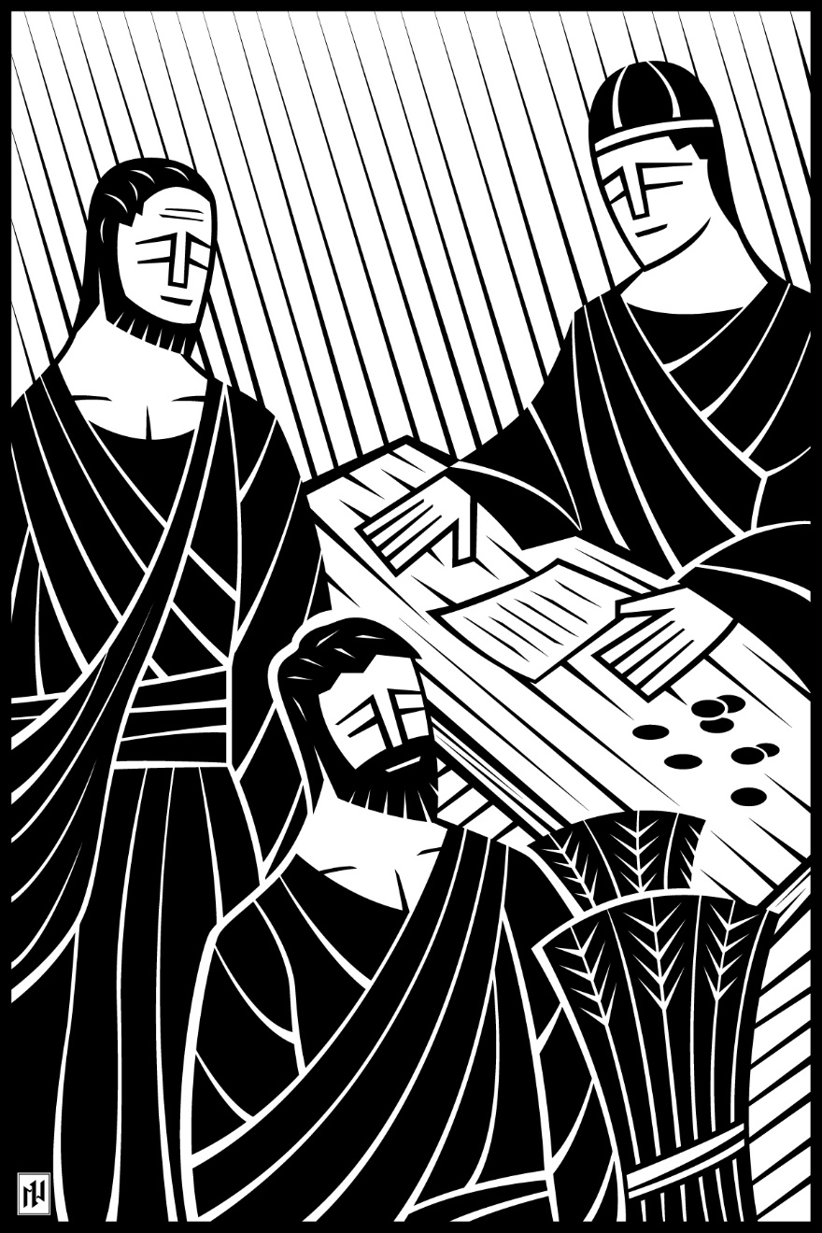
18th Sunday after Pentecost
Christians Manage Their God-Given Possessions to His Glory
October 10 and 13, 2019

In the name of our Lord Jesus, welcome! We pray that within our church you will find the quiet assurance of God’s presence, the warmth of Christian fellowship, and the abiding truth of God’s Word. Come worship with us again!

FOR VISITORS___________________________________________
- Visitor Cards: If this is your first visit to Zion, welcome! Please fill out a blue visitor card. You will find them in the pew racks and on the media counter in the lobby.
- Restrooms: The main restrooms are located just off the lobby. A family restroom is located down the hall from the library.
- Parents: You may use the library, lobby or fellowship hall for nursing or other childcare. Changing stations are provided in all restrooms.
- Sound: Hearing assistance is available for your use. Both the sanctuary and fellowship hall are equipped with hearing loops. Please set your hearing aid to the T (telecoil) setting. Portable audio receivers are also available from the ushers.
- Information: The media counter is located in the entryway. Here you will find magazines, brochures, devotional booklets, children’s bulletins, and more.
- Contact: Our pastors and principal are here to serve you. Contact information is provided below.

SERVING TODAY___________________________________________
Preaching Pastor Benjamin Zuberbier
Presiding Pastor Timothy Schwartz
Organist Marie Becker
Ushers (8:00) Kim Schilling, Ronald Knudson, Andy Tratar, John Zandler,
Scott Brenner, Matt Vosberg
Ushers (10:30) Matt Huber, Carter Huber, Jeremy Maas, Tony Owens
Peter Klokow, Jack Klokow
Greeters (8:00) Wilma Lenz and Joan Herzberg
Greeters (10:30) Janell Allar and Kay Salzwedel
Video Gary Schuhmacher

CONTACT US___________________________________________
Website zioncolumbus.org
Office Phone 920-623-5180
Office Email office@zioncrusaders.com
Church Address 812 Western Avenue
School Address 822 Western Avenue
Pastor Ben Zuberbier 920-517-7940; pastorbenzuberbier@gmail.com
Pastor Tim Schwartz 509-480-2967; tschwartz24@gmail.com
Principal Alex Vandenberg 507-353-0719; avandenberg@zioncrusaders.com

SERVICE OF THE WORD

K4 and K5 SING | 8:00 Race of Life words and melody by Jan Nelson

When the race of life seems long and hard
And Satan tries to block your every move,
Just keep in mind across that finish line
The Savior's waiting patiently for you.
So, run the good race with all your might,
Trust in the Lord and fight the good fight.
Keep Jesus Christ before your eyes.
He's won the victory; heaven's the prize.

And if you get lost along the way
Or feel that you just cannot stand the test,
Don't despair, just cast on Him your care.
He'll strengthen you and give you His success.
So, run the good race with all your might,
Trust in the Lord and fight the good fight.
Keep Jesus Christ before your eyes.
He's won the victory; heaven's the prize.

OPENING HYMN Lord, You Love the Cheerful Giver | CW 489

The grace of our Lord (†) Jesus Christ and the love of God and the fellowship of the Holy Spirit be with you.
And also with you.
CONFESSION OF SINS

We have come into the presence of God, who created us to love and serve him as his dear children. But we have disobeyed him and deserve only his wrath and punishment. Therefore, let us confess our sins to him and plead for his mercy.
Merciful Father in heaven, I am altogether sinful from birth. In countless ways I have sinned against you and do not deserve to be called your child. But trusting in Jesus, my Savior, I pray: Have mercy on me according to your unfailing love. Cleanse me from my sin, and take away my guilt.

ABSOLUTION
God, our heavenly Father, has forgiven all your sins. By the perfect life and innocent death of our Lord Jesus Christ, he has removed your guilt forever. You are his own dear child. May God give you strength to live according to his will!
Amen.
PRAYER AND PRAISE

In the peace of forgiveness, let us praise the Lord.
OH, TASTE AND SEE

PRAYER OF THE DAY
Lord God, you call us to work in your kingdom and leave no one standing idle. Help us to order our lives by your wisdom and to serve you in willing obedience; through Jesus Christ, your Son, our Lord, who lives and reigns with you and the Holy Spirit, one God, now and forever.

THE WORD

FIRST LESSON Genesis 14:8-24 | NIV
T
hen the king of Sodom, the king of Gomorrah, the king of Admah, the king of Zeboyim and the king of Bela (that is, Zoar) marched out and drew up their battle lines in the Valley of Siddim ⁹ against Kedorlaomer king of Elam, Tidal king of Goyim, Amraphel king of Shinar and Arioch king of Ellasar—four kings against five. ¹⁰ Now the Valley of Siddim was full of tar pits, and when the kings of Sodom and Gomorrah fled, some of the men fell into them and the rest fled to the hills. ¹¹ The four kings seized all the goods of Sodom and Gomorrah and all their food; then they went away. ¹² They also carried off Abram’s nephew Lot and his possessions, since he was living in Sodom.
¹³ A man who had escaped came and reported this to Abram the Hebrew. Now Abram was living near the great trees of Mamre the Amorite, a brother of Eshkol and Aner, all of whom were allied with Abram. ¹⁴ When Abram heard that his relative had been taken captive, he called out the 318 trained men born in his household and went in pursuit as far as Dan. ¹⁵ During the night Abram divided his men to attack them and he routed them, pursuing them as far as Hobah, north of Damascus. ¹⁶ He recovered all the goods and brought back his relative Lot and his possessions, together with the women and the other people.
¹⁷ After Abram returned from defeating Kedorlaomer and the kings allied with him, the king of Sodom came out to meet him in the Valley of Shaveh (that is, the King’s Valley).
¹⁸ Then Melchizedek king of Salem brought out bread and wine. He was priest of God Most High, ¹⁹ and he blessed Abram, saying,
“Blessed be Abram by God Most High,
Creator of heaven and earth.
²⁰ And praise be to God Most High,
who delivered your enemies into your hand.”
Then Abram gave him a tenth of everything.
²¹ The king of Sodom said to Abram, “Give me the people and keep the goods for yourself.”
²² But Abram said to the king of Sodom, “With raised hand I have sworn an oath to the Lord, God Most High, Creator of heaven and earth, ²³ that I will accept nothing belonging to you, not even a thread or the strap of a sandal, so that you will never be able to say, ‘I made Abram rich.’ ²⁴ I will accept nothing but what my men have eaten and the share that belongs to the men who went with me—to Aner, Eshkol and Mamre. Let them have their share.”

PSALM OF THE DAY CW Psalm 38

O LORD, do not rebuke me in your anger*
or discipline me in your wrath.

For your arrows have pierced me,*
and your hand has come down upon me.

My guilt has overwhelmed me*
like a burden too heavy to bear.

Refrain

All my longings lie open before you, O LORD;*
my sighing is not hidden from you.

I wait for you, O LORD;*
you will answer, O Lord my God.

Come quickly to help me,*
O Lord my Savior.

Glory be to the Father and to the Son*
and to the Holy Spirit,
as it was in the beginning,*
is now, and will be forever. Amen.

Refrain

SECOND LESSON I Timothy 6:6-16 | NIV
B
ut godliness with contentment is great gain. ⁷ For we brought nothing into the world, and we can take nothing out of it. ⁸ But if we have food and clothing, we will be content with that. ⁹ Those who want to get rich fall into temptation and a trap and into many foolish and harmful desires that plunge people into ruin and destruction. ¹⁰ For the love of money is a root of all kinds of evil. Some people, eager for money, have wandered from the faith and pierced themselves with many griefs.
¹¹ But you, man of God, flee from all this, and pursue righteousness, godliness, faith, love, endurance and gentleness. ¹² Fight the good fight of the faith. Take hold of the eternal life to which you were called when you made your good confession in the presence of many witnesses. ¹³ In the sight of God, who gives life to everything, and of Christ Jesus, who while testifying before Pontius Pilate made the good confession, I charge you ¹⁴ to keep this command without spot or blame until the appearing of our Lord Jesus Christ, ¹⁵ which God will bring about in his own time—God, the blessed and only Ruler, the King of kings and Lord of lords, ¹⁶ who alone is immortal and who lives in unapproachable light, whom no one has seen or can see. To him be honor and might forever. Amen.

VERSE OF THE DAY

CHILDREN’S LESSON An Offering is a “Thank You”

GOSPEL Luke 16:1-13 | NIV
J
esus told his disciples: “There was a rich man whose manager was accused of wasting his possessions. ² So he called him in and asked him, ‘What is this I hear about you? Give an account of your management, because you cannot be manager any longer.’
³ “The manager said to himself, ‘What shall I do now? My master is taking away my job. I’m not strong enough to dig, and I’m ashamed to beg—⁴ I know what I’ll do so that, when I lose my job here, people will welcome me into their houses.’
⁵ “So he called in each one of his master’s debtors. He asked the first, ‘How much do you owe my master?’
⁶ “ ‘Nine hundred gallons of olive oil,’ he replied.
“The manager told him, ‘Take your bill, sit down quickly, and make it four hundred and fifty.’
⁷ “Then he asked the second, ‘And how much do you owe?’
“ ‘A thousand bushels of wheat,’ he replied.
“He told him, ‘Take your bill and make it eight hundred.’
⁸ “The master commended the dishonest manager because he had acted shrewdly. For the people of this world are more shrewd in dealing with their own kind than are the people of the light. ⁹ I tell you, use worldly wealth to gain friends for yourselves, so that when it is gone, you will be welcomed into eternal dwellings.
¹⁰ “Whoever can be trusted with very little can also be trusted with much, and whoever is dishonest with very little will also be dishonest with much. ¹¹ So if you have not been trustworthy in handling worldly wealth, who will trust you with true riches? ¹² And if you have not been trustworthy with someone else’s property, who will give you property of your own?
¹³ “No one can serve two masters. Either you will hate the one and love the other, or you will be devoted to the one and despise the other. You cannot serve both God and money.”

This is the Gospel of the Lord.

HYMN OF THE DAY All Depends on Our Possessing | CW 421

SERMON The Christian Serves God, Not Money | Luke 16:1-13 | NIV
- He Will Give You Eternal Riches
- So You Manage Money for Ministry

APOSTLES’ CREED
I believe in God, the Father almighty, maker of heaven and earth.
I believe in Jesus Christ, his only Son, our Lord, who was conceived by the Holy Spirit, born of the virgin Mary, suffered under Pontius Pilate, was crucified, died, and was buried. He descended into hell. The third day he rose again from the dead. He ascended into heaven and is seated at the right hand of God the Father almighty. From there he will come to judge the living and the dead.
I believe in the Holy Spirit, the holy Christian Church, the communion of saints, the forgiveness of sins, the resurrection of the body, and the life everlasting. Amen.

OFFERING

OFFERING PRAYER
All things we have come from and belong to you, O God. Guide us, therefore, to use all we have to the glory of your name and for the good of your kingdom. Take our hearts and fill them with your love; take our lips and move them to speak of Jesus; take our lives and use them to serve in your church. Move us, by the Spirit of Jesus, to do what is needed to spread the gospel of Jesus worldwide for his name’s sake.
Amen.

PRAYER OF THE CHURCH
Lord of our lives, by sending your Son to live and die as our perfect substitute, you provided forgiveness and salvation for a world of sinners. We praise you for your generous saving love. We thank you for reaching out to each of us personally with your Word and the water of Baptism.
You have set us apart as people who belong to you, people whose purpose in life is to receive your love and live to your glory.
Gracious Father, remind us that you have called us to live for you and not for ourselves or according to the standards of the world. Help us to devote our time, our talents, our energy, and whatever you have placed into our hands to those things that will be of value for eternity. Help us to love you and others and to use things as you desire, instead of loving things and trying to use you and others for our own selfish desires.
May our hearts belong to you completely so that our lives can be devoted to things that really matter.
Bless all who are suffering or in need. Be with the lonely and the grief-stricken. Move us to use the unique gifts you have given each of us to bring comfort and help to those who need it.
Bless the government and the Church and make us blessings to both.
Special prayers and intercessions may follow.
Hear us, Lord, as we bring you our private petitions.
Silent prayer.
Crush the self-centeredness that comes to us naturally and fill us with joyful generosity. Grant that the gifts we bring to you may show that we are just as diligent and just as interested in carrying out your business as we are in carrying out our own.
We dare to ask all this, Father, not because we deserve to ask it but because your Son has earned for us the right to approach you as your dear children. Amen.

LORD’S PRAYER
Our Father in heaven, hallowed be your name, your kingdom come, your will be done on earth as in heaven. Give us today our daily bread. Forgive us our sins, as we forgive those who sin against us. Lead us not into temptation, but deliver us from evil. For the kingdom, the power, and the glory are yours now and forever. Amen.

HYMN I Am Content! My Jesus Lives Again | CW 158

O Lord God, our heavenly Father, pour out the Holy Spirit on your faithful people. Keep us strong in your grace and truth, protect and comfort us in all temptation, and bestow on us your saving peace, through Jesus Christ, our Lord, who lives and reigns with you and the Holy Spirit, one God, now and forever.

Brothers and sisters, go in peace. Live in harmony with one another. Serve the Lord with gladness.
The Lord bless you and keep you.
The Lord make his face shine on you and be gracious to you.
The Lord look on you with favor and (†) give you peace.

CLOSING HYMN Brothers, Sisters, Let Us Gladly | CW 484

Acknowledgements
- All copyrighted materials reprinted under OneLicense.net # A-712592
- Lord, You Love the Cheerful Giver Setting: © 1986 by GIA Publications, Inc., Chicago, IL. All rights reserved. Used by permission.
- Oh, Taste and See: Verse: Tune and Setting: Kermit G. Moldenhauer. © 1993. . All rights reserved. Used by permission.
- Psalm 38: Refrain Tune: Patricia Craig. © 1986 GIA Publications, Inc., Chicago, IL, www.giamusic.com. All rights reserved. Used by permission. Psalm Tone: Paul Bunjes. © 1982 Concordia Publishing House. All rights reserved. Used by permission.
- All images are from Paramentics.com or the WELS Hymnal Project Website, done by Ian Welch © 2013. All images are all rights reserved. Used by permission.

