In the name of our Lord Jesus, welcome! We pray that within our church you will find the quiet assurance of God’s presence, the warmth of Christian fellowship, and the abiding truth of God’s Word. Come worship with us again!

FOR VISITORS___________________________________________
- Visitor Cards: If this is your first visit to Zion, welcome! Please fill out a blue visitor card. You will find them in the pew racks and on the media counter in the lobby.
- Restrooms: The main restrooms are located just off the lobby. A family restroom is located down the hall from the library.
- Parents: You may use the library, lobby or fellowship hall for nursing or other childcare. Changing stations are provided in all restrooms.
- Sound: Hearing assistance is available for your use. Both the sanctuary and fellowship hall are equipped with hearing loops. Please set your hearing aid to the T (telecoil) setting. Portable audio receivers are also available from the ushers.
- Information: The media counter is located in the entryway. Here you will find magazines, brochures, devotional booklets, children’s bulletins, and more.
- Contact: Our pastors and principal are here to serve you. Contact information is provided below.

SERVING TODAY___________________________________________
Preaching Pastor Timothy Schwartz
Presiding Pastor Benjamin Zuberbier
Organist Rachel Grambsch
Ushers (8:00) Jim Greiling, Matt Greiling, Mike Sommer, Hunter Sommer, John Brey,
Bob Marousek, Jordan Crave
Ushers (10:30) Tom Schultz, George Decker, Aaron Larson, James Kopfer, Dayne Kopfer,
Brandon Lee, Brian Vierck
Communion Assistant (8:00) Jeff Krakow
Communion Assistant (10:30) Dave Harle
Greeters (8:00) Gene Beier
Greeters (10:30) Rick & Lisa Gentz
Video Mark Lindell

CONTACT US___________________________________________
Website zioncolumbus.org
Office Phone 920-623-5180
Office Email office@zioncrusaders.com
Church Address 812 Western Avenue
School Address 822 Western Avenue
Pastor Ben Zuberbier 920-517-7940; pastorbenzuberbier@gmail.com
Pastor Tim Schwartz 509-480-2967; tschwartz24@gmail.com
Principal Alex Vandenberg 507-353-0719; avandenberg@zioncrusaders.com
COPYRIGHT INFORMATION
Greek cross image: © Ian Welch www.paramentics.com. Used by permission.
To God on High Be Glory: © Michael Schultz. Used by permission.
Psalm 133—How Very Good and Pleasant: Refrain © Barbara Boertje; refrain setting and verse music © Dale Witte.
Verse text © Dale Witte and Kira Frederick. Used by permission.
Sanctus and Agnus Dei: © 1991 David Schack. Used by permission.
Oh, How Good It Is: © 2012 Getty Music Publishing (BMI) (admin. by Music Services) / Parakeet Boots Music (ASCAP) (admin. by Getty Music Publishing c/o Music Services) / Townend Songs (PRS) (admin. in North America by Music Services and
elsewhere by Song Solutions) All Rights Reserved.
Son of God, Eternal Savior. Setting: © 1986 James E. Engel. Used by permission of Mrs. James E. Engel
Our Worship Series
Read through Scripture and count the times it refers to believers as “brothers and sisters.” You will reach the triple digits quickly. The Holy Spirit is deliberate with his choice of words. If he frequently refers to the Church in those terms, there can be only one explanation. He wants us to think of each other as family. We understand the important roles a mother and father play. We know the joys (and challenges) of having siblings. Do we grasp that it is just as important that we have a spiritual family? Scripture teaches that what unites us to our spiritual family is infinitely more powerful than any biological bond. Moreover, you can lose a blood relative. They can be taken away from you by death. But you will enjoy the companionship of your spiritual family for all eternity. In this worship series, we will look at how our Father knits us together in love and unity into a spiritual family. We will see the benefits of being part of this family. In the Church, Christ has given us a better home.
Welcome Home!
Our Need for Christian Community
The Lost Are Now Found
You Are Free to Be Yourself
You Are Perfectly Safe Here
You Have an Everlasting Family
You are Part of Christ’s Glorious Kingdom

Our Theme for Today
“Army of One” was the shortest-lived recruiting slogan in US military history. It was meant to stress the strength of the individual. The Army dropped the slogan relatively quickly because they realized it was contrary to the reality that, in the army, you are completely reliant upon your team. In a stressful situation, the individual can be overwhelmed. He or she needs others. God knows this. The first time God looked at Creation and noticed something was off, the issue was that an individual (Adam) was isolated. “It is not good for the man to be alone” (Genesis 2:18). Humans are hardwired by God to need fellowship, not just with him, but with one another. So, God is determined to bring believers into a loving, nurturing community—the Church.
Perhaps you have been a part of this Christian family for a long time. Perhaps you once belonged to a church, but for whatever reason drifted away. Perhaps you have never belonged to a church. Whatever may be the case for you, may God bless you as you listen to his Word today. May he help us all to realize that this Christian community—this spiritual home—is something we badly need. Welcome home!
This service offers the congregation a form of worship that focuses on the proclamation of God’s Word and the celebration of Holy Communion.
SERVICE OF WORD & SACRAMENT
† Gathering †

OPENING HYMN — Love Divine, All Love Excelling | CW 365
INVOCATION
In the name of the Father and of the  Son and of the Holy Spirit.
Amen.
Confession and absolution
God has called us to live as family. Yet, our love for God and for each other is not what it should be. Our priorities and choices are often flawed. But the power of God’s love enables us to live a new life. Let us confess our sins to God and ask for his forgiveness.
Almighty God, merciful Father, I confess to you that I have not loved you with all my heart. In what I have done and left undone, I have pursued my ways instead of your ways. I have not loved my brothers and sisters as myself. For this I deserve your punishment both now and in eternity. I am truly sorry for my sins. I repent of them.
I beg for your mercy, O Lord.
Silence for meditation
Forgive us for the sake of Jesus Christ who suffered and died for us.
Lord, have mercy. Christ, have mercy. Lord, have mercy.
God has been merciful to us and has sent his Son to die for all. For his sake, God forgives our sins and empowers us to be his people. Therefore, as a called servant of Christ and by his authority, I forgive you all your sins in the name of the Father and of the  Son and of the Holy Spirit.
Amen.

Our Lord Jesus Christ has forgiven us and reconciled us to God and has promised us the power to forgive and love each other. In the peace of forgiveness, let us praise the Lord.

After a brief introduction, all sing:
TO GOD ON HIGH BE GLORY Gloria in Excelsis
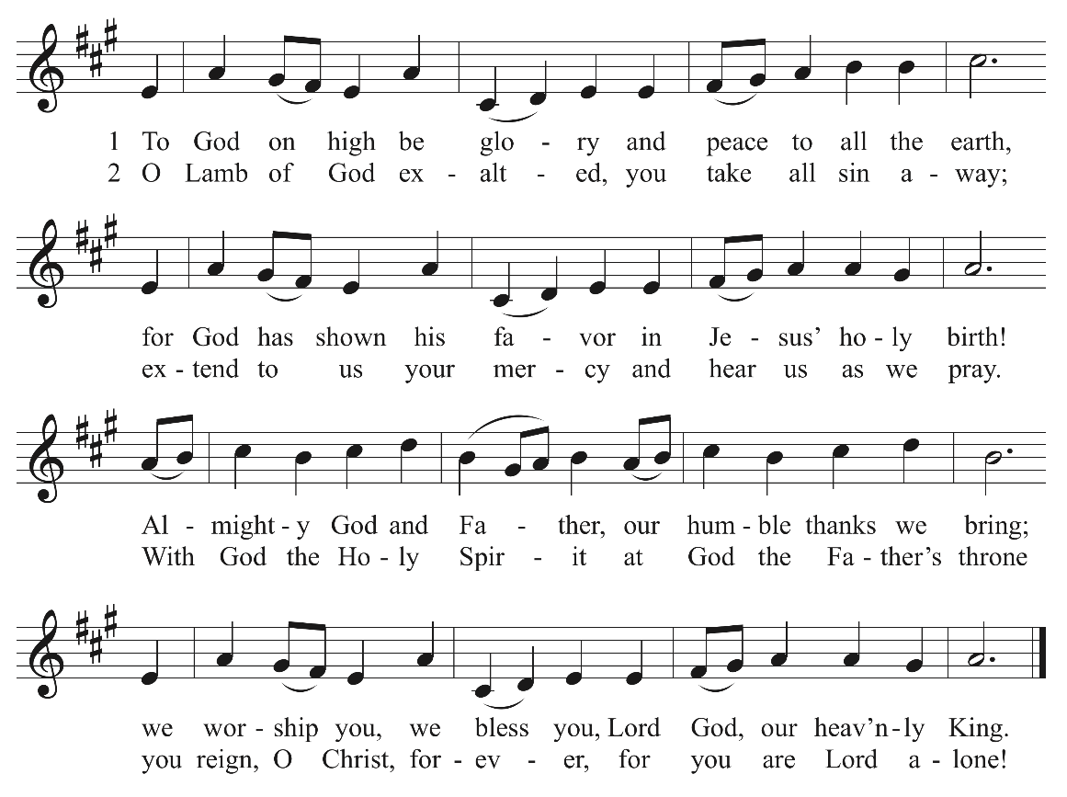

PRAYER OF THE DAY
O Lord Jesus Christ, preserve the family of believers with your never-failing mercy. Bind us together with the bond of your love. Help us avoid whatever is wicked and harmful, and guide us in the way that leads to our salvation; for you live and reign with the Father and the Holy Spirit, one God, now and forever.
Amen.
† The Word †

FIRST LESSON Ecclesiastes 4:7-12
Scripture says that people are not wired to be rugged individuals. God created us to need
one another. Two are better than one. Even better is having Christ as the third strand
within a relationship. He provides the love and grace that keeps that bond strong.
⁷ Again I saw something meaningless under the sun:
⁸ There was a man all alone;
he had neither son nor brother.
There was no end to his toil,
yet his eyes were not content with his wealth.
“For whom am I toiling,” he asked,
“and why am I depriving myself of enjoyment?”
This too is meaningless—
a miserable business!
⁹ Two are better than one,
because they have a good return for their labor:
¹⁰ If either of them falls down,
one can help the other up.
But pity anyone who falls
and has no one to help them up.
¹¹ Also, if two lie down together, they will keep warm.
But how can one keep warm alone?
¹² Though one may be overpowered,
two can defend themselves.
A cord of three strands is not quickly broken.

PSALM OF THE DAY Psalm 133

Cantor: Refrain
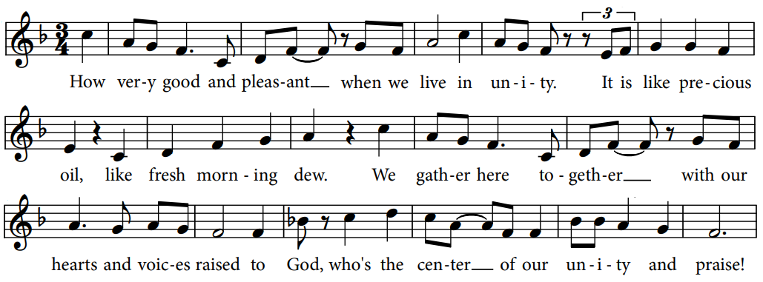

Cantor: Together, together we lift our voices to the Lord.
Together, together we shout our praise to his name.
ALL: Refrain
Cantor: Through water and his Word the Spirit makes us family.
Salvation and new life are ours to share with everyone.
ALL: Refrain
Cantor: You servants of the Lord, now in his house lift up your hands and praise
the Lord who made the heavens and the earth.
ALL: Refrain

SECOND LESSON Hebrews 2:9-18
Jesus became our brother so that by his suffering, death and resurrection he might
unite us to himself and knit us together into a spiritual family

⁹ But we do see Jesus, who was made lower than the angels for a little while, now crowned with glory and honor because he suffered death, so that by the grace of God he might taste death for everyone.
¹⁰ In bringing many sons and daughters to glory, it was fitting that God, for whom and through whom everything exists, should make the pioneer of their salvation perfect through what he suffered. ¹¹ Both the one who makes people holy and those who are made holy are of the same family. So Jesus is not ashamed to call them brothers and sisters. ¹² He says,
“I will declare your name
to my brothers and sisters;
in the assembly I will sing your praises.”
¹³ And again,
“I will put my trust in him.”
And again he says,
“Here am I, and the children God has given me.”
¹⁴ Since the children have flesh and blood, he too shared in their humanity so that by his death he might break the power of him who holds the power of death—that is, the devil— ¹⁵ and free those who all their lives were held in slavery by their fear of death. ¹⁶ For surely it is not angels he helps, but Abraham’s descendants. ¹⁷ For this reason he had to be made like them, fully human in every way, in order that he might become a merciful and faithful high priest in service to God, and that he might make atonement for the sins of the people. ¹⁸ Because he himself suffered when he was tempted, he is able to help those who are being tempted.

VERSE OF THE DAY
Alleluia! I will declare your name to my brothers and sisters;
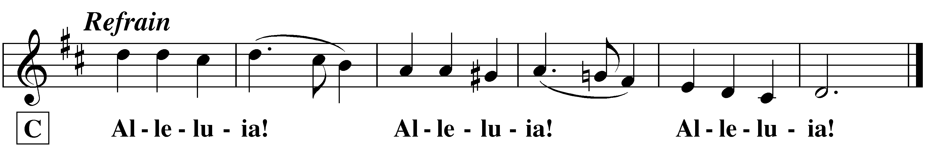
in the assembly I will sing your praises. Alleluia!

GOSPEL Matthew 11:25-30
Jesus wants us in his family so that he might give us rest and peace.

²⁵ At that time Jesus said, “I praise you, Father, Lord of heaven and earth, because you have hidden these things from the wise and learned, and revealed them to little children. ²⁶ Yes, Father, for this is what you were pleased to do.
²⁷ “All things have been committed to me by my Father. No one knows the Son except the Father, and no one knows the Father except the Son and those to whom the Son chooses to reveal him.
²⁸ “Come to me, all you who are weary and burdened, and I will give you rest. ²⁹ Take my yoke upon you and learn from me, for I am gentle and humble in heart, and you will find rest for your souls. ³⁰ For my yoke is easy and my burden is light.”

This is the Gospel of our Lord.
Praise be to you, O Christ!

HYMN OF THE DAY God Is Here! As We His People | CW 532

SERMON It’s Time for A Come to Jesus Moment Matthew 11:25-30 | NIV

CONFESSION OF FAITH Apostles’ Creed
I believe in God, the Father almighty, maker of heaven and earth.
I believe in Jesus Christ, his only Son, our Lord, who was conceived by the Holy Spirit, born of the virgin Mary, suffered under Pontius Pilate, was crucified, died, and was buried. He descended into hell. The third day he rose again from the dead. He ascended into heaven, and is seated at the right hand of God the Father almighty. From there he will come to judge the living and the dead.
I believe in the Holy Spirit, the holy Christian Church, the communion of saints, the forgiveness of sins, the resurrection of the body, and the life everlasting. Amen.

OFFERING
† Prayers †

PRAYER OF THE CHURCH
Prayers and petitions are made on behalf of the Church
Hear us, Lord, as we bring you our private petitions.
Silent prayer

LORD’S PRAYER
We pray in Jesus’ name and as he taught.
Our Father in heaven,
hallowed be your name,
your kingdom come,
your will be done on earth as in heaven.
Give us today our daily bread.
Forgive us our sins, as we forgive those who sin against us.
Lead us not into temptation,
but deliver us from evil.
For the kingdom, the power, and the glory are yours now and forever.
Amen.
† Holy Communion †

The Lord be with you.
And also with you.
Lift up your hearts.
We lift them up to the Lord.
Let us give thanks to the Lord our God.
It is right to give him thanks and praise.
Praise to the God and Father of our Lord Jesus Christ!
In love he has blessed us with every spiritual blessing.
He sends his Holy Spirit to testify that we are his children
and to strength us when we are weak.
Now have come the salvation and the power and the kingdom of our God
and the authority of his Christ.
To him who sits on the throne and to the Lamb
be praise and thanks and honor and glory for ever and ever.
HOLY, HOLY, HOLY Sanctus
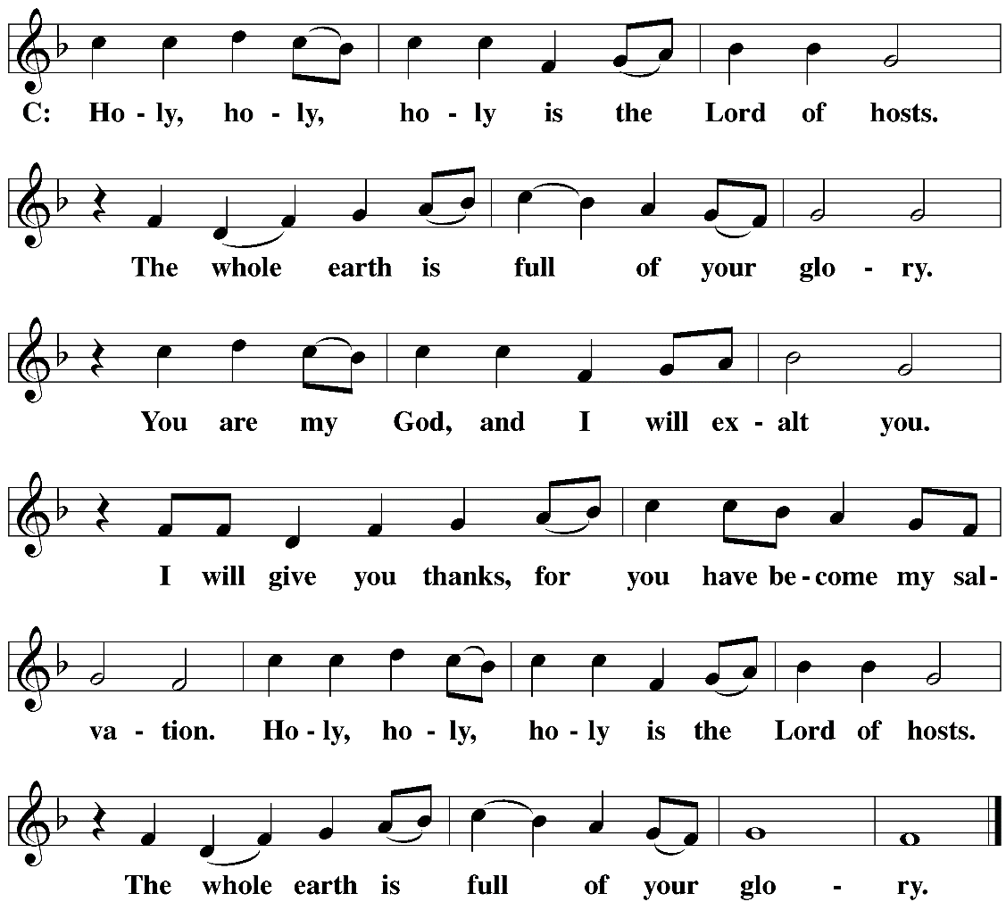

WORDS OF INSTITUTION
Our Lord Jesus Christ, on the night he was betrayed, took bread; and when he had given thanks, he broke it and gave it to his disciples, saying, “Take and eat; this is my  body, which is given for you. Do this in remembrance of me.”
Then he took the cup, gave thanks, and gave it to them, saying, “Drink from it, all of you; this is my  blood of the new covenant, which is poured out for you for the forgiveness of sins. Do this, whenever you drink it, in remembrance of me.”
The peace of the Lord be with you always.
Amen.
COMMUNING AT ZION
Communion: If you are visiting today we ask you to speak to one of our pastors before communing. We follow the Biblical, ancient custom of close communion (also called “member communion”).
Confession: Receiving Holy Communion is a statement of faith. Any person who takes communion with a group of believers is publicly saying, “I believe everything this church teaches.”
Instruction: In order for people to understand the teachings that they are confessing when they take communion, we offer classes on the Christian faith in our church (and all of our WELS and ELS churches). We ask all visitors who have not yet received such instruction to first go through the classes before taking part in the Lord’s Supper.
O CHRIST, LAMB OF GOD Agnus Dei
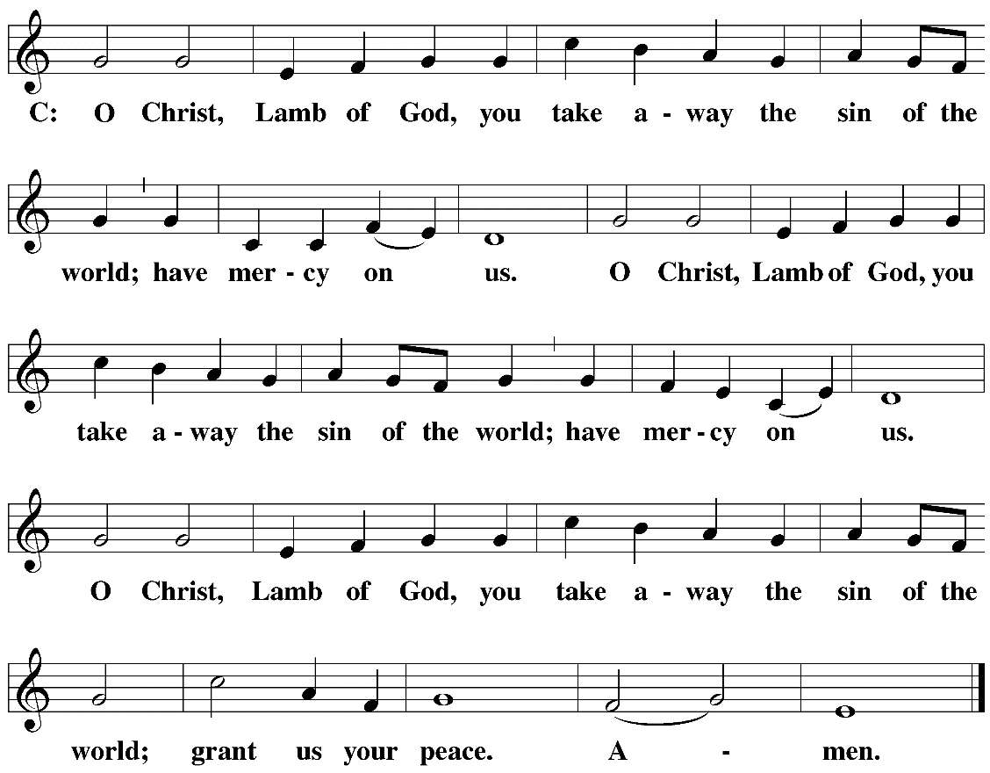

DISTRIBUTION HYMNS Son of God, Eternal Savior | CW492
I Come , O Savior, to Your Table | CW 310

CLOSING PRAYER
We give you thanks, O Lord, for the foretaste of the heavenly banquet that you have given us to eat and to drink in this sacrament. Through this gift you have fed our faith, nourished our hope, and strengthened our love. By your Spirit help us to live as your holy people until that day when you will receive us as your guests at the wedding supper of the Lamb, who lives and reigns with you and the Holy Spirit, one God, now and forever.
Amen.

BLESSING
Brothers and sisters, go in peace.
Live in harmony with one another.
Serve the Lord with gladness.
The Lord bless you and keep you.
The Lord make his face shine on you and be gracious to you.
The Lord look on you with favor and give  you peace.
Amen.
CLOSING HYMN Oh, How Good It Is

