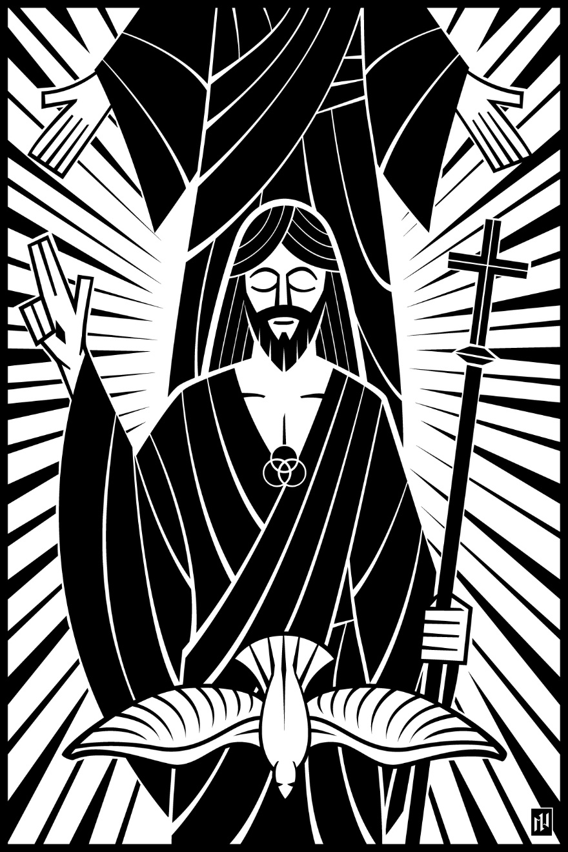

1st Sunday after Pentecost – Holy Trinity
The Believer Follows…The One True God
June 13 and 16, 2019
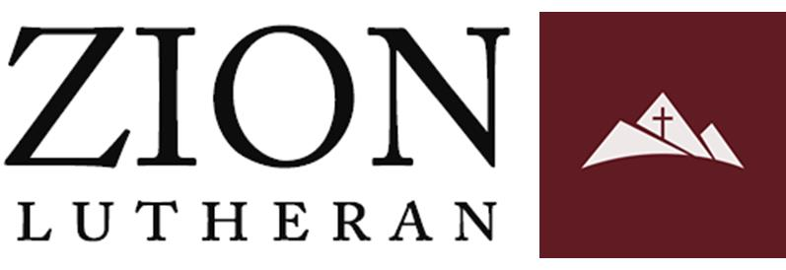
In the name of our Lord Jesus, welcome! We pray that within our church you will find the quiet assurance of God’s presence, the warmth of Christian fellowship, and the abiding truth of God’s Word. Come worship with us again!

FOR VISITORS___________________________________________
• Visitor Cards: If this is your first visit to Zion, welcome! Please fill out a blue visitor card. You will find them in the pew racks and on the media counter in the lobby.
• Restrooms: The main restrooms are located just off the lobby. A family restroom is located down the hall from the library.
• Parents: You may use the library, lobby or fellowship hall for nursing or other childcare. Changing stations are provided in all restrooms.
• Sound: Hearing assistance is available for your use. Both the sanctuary and fellowship hall are equipped with hearing loops. Please set your hearing aid to the T (telecoil) setting. Portable audio receivers are also available from the ushers.
• Information: The media counter is located in the entryway. Here you will find magazines, brochures, devotional booklets, children’s bulletins, and more.
• Contact: Our pastors and principal are here to serve you. Contact information is provided below.

SERVING TODAY___________________________________________
Preaching Pastor Timothy Schwartz
Presiding Pastor Robert Wilke
Organist Rachel Grambsch
Ushers (8:00) Randy Koehn, Jadon Schwartz, Joe Grambsch, Ben Grambsch,
Josiah Schwartz, Jim Stadler
Ushers (10:30) Phil Manteufel, Peter Lewke, Dave Harle, Paul Musser, Brian Baney, Eric Musser
Communion Assistant (8:00) Leo Fischer
Communion Assistant (10:30) Aaron Larson
Greeters (8:00) Jeff & Melody Krakow
Greeters (10:30) Wayne & Darlene Powers
Video Gary Schuhmacher

CONTACT US___________________________________________
Website zioncolumbus.org
Office Phone 920-623-5180
Office Email office@zioncrusaders.com
Church Address 812 Western Avenue
School Address 822 Western Avenue
Pastor Robert Wilke 920-623-4870; revrwilke@gmail.com
Pastor Tim Schwartz 509-480-2967; tschwartz24@gmail.com
Principal Alex Vandenberg 507-353-0719; avandenberg@zioncrusaders.com
DIVINE SERVICE I

OPENING HYMN Holy, Holy, Holy, Lord God Almighty | CW 195, v 1-3

Minister: In the name of the Father and of the Son and of the Holy Spirit.
Congregation: Amen.

CONFESSION OF SINS
M: Beloved in the Lord: let us draw near with a true heart and confess our sins to God our Father, asking him in the name of our Lord Jesus Christ to grant us forgiveness.
C: Holy and merciful Father, I confess that I am by nature sinful and that I have disobeyed you in my thoughts, words, and actions. I have done what is evil and failed to do what is good. For this I deserve your punishment both now and in eternity. But I am truly sorry for my sins, and trusting in my Savior Jesus Christ, I pray: Lord, have mercy on me, a sinner.

LORD, HAVE MERCY |Kyrie

M: God, our heavenly Father, has been merciful to us and has given his only Son to be the atoning sacrifice for our sins. Therefore, as a called servant of Christ and by his authority, I forgive you all your sins in the name of the Father and of the Son (†) and of the Holy Spirit.
C: Amen.

PRAYER AND PRAISE
M: In the peace of forgiveness, let us praise the Lord.
C: Holy, holy, holy! Lord God Almighty! CW 195, v 4
All thy works shall praise thy name
In earth and sky and sea.
Holy, holy, holy, merciful and mighty,
God in three persons, blessed Trinity!

PRAYER OF THE DAY
M: The Lord be with you.
C: And also with you.
M: Let us pray. Almighty God and Father, dwelling in majesty and mystery, filling and renewing all creation by your eternal Spirit, and manifesting your saving grace through our Lord Jesus Christ: in mercy cleanse our hearts and lips that, free from doubt and fear, we may ever worship you, one true immortal God, with your Son and the Holy Spirit, living and reigning, now and forever.
C: Amen.

THE WORD

FIRST LESSON Numbers 6: 22-27 | NIV
T
he Lord said to Moses, ²³ “Tell Aaron and his sons, ‘This is how you are to bless the Israelites. Say to them:
²⁴ “ ‘ “The Lord bless you
and keep you;
²⁵ the Lord make his face shine on you
and be gracious to you;
²⁶ the Lord turn his face toward you
and give you peace.” ’
²⁷ “So they will put my name on the Israelites, and I will bless them.”

THE ATHANASIAN CREED | Part 1
M: Whoever wishes to be saved must, above all else, hold to the true Christian faith. Whoever does not keep this faith pure in all points will certainly perish forever.
Now this is the true Christian faith:
C: We worship one God in three persons and three persons in one God, without mixing the persons or dividing the divine being.
M: For each person - the Father, the Son, and the Holy Spirit - is distinct, but the deity of Father, Son, and Holy Spirit is one, equal in glory and coeternal in majesty.
What the Father is, so is the Son, and so is the Holy Spirit. The Father is uncreated, the Son uncreated, the Holy Spirit uncreated; the Father is infinite, the Son infinite, the Holy Spirit infinite. The Father is eternal, the Son eternal, the Holy Spirit eternal:
C: Yet they are not three who are eternal, but there is one who is eternal, just as they are not three who are uncreated, nor three who are infinite. But there is one who is uncreated and one who is infinite.
M: In the same way the Father is almighty. The Son is almighty, the Holy Spirit is almighty, Yet they are not three who are almighty, but there is one who is almighty.
C: So the Father is God, the Son is God, the Holy Spirit is God: Yet there are not three Gods, but one God.
M: So the Father is Lord, the Son is Lord, the Holy Spirit is Lord:
C: Yet there are not three Lords, but one Lord.
M: For just as Christian faith compels us to confess each person individually to be God and Lord,
So the true Christian faith forbids us to speak of three Gods or three Lords.
C: The Father is neither made nor created nor begotten of anyone.
The Son is, neither made nor created, but is begotten of the Father alone.
The Holy Spirit is neither made nor created nor begotten, but proceeds from the Father and the Son.
M: There is one Father, not three Fathers; one Son, not three Sons; Holy Spirit, not three Holy Spirits. And within this Trinity none comes before or after; none is greater or inferior, but all three persons are coequal and coeternal, in every way, as stated before, all three persons are to be worshipped as one God and one God worshipped as three persons.
C: Whoever wishes to be saved must have this conviction of the Trinity.

SECOND LESSON I John 5:5-12 | NIV
W
ho is it that overcomes the world? Only the one who believes that Jesus is the Son of God.
⁶ This is the one who came by water and blood—Jesus Christ. He did not come by water only, but by water and blood. And it is the Spirit who testifies, because the Spirit is the truth. ⁷ For there are three that testify: ⁸ the Spirit, the water and the blood; and the three are in agreement. ⁹ We accept human testimony, but God’s testimony is greater because it is the testimony of God, which he has given about his Son. ¹⁰ Whoever believes in the Son of God accepts this testimony. Whoever does not believe God has made him out to be a liar, because they have not believed the testimony God has given about his Son. ¹¹ And this is the testimony: God has given us eternal life, and this life is in his Son. ¹² Whoever has the Son has life; whoever does not have the Son of God does not have life.

THE ATHANASIAN CREED | Part 2
M: It is furthermore necessary for eternal salvation truly to believe that our Lord Jesus Christ also took on human flesh.
Now this is the true Christian faith:
C: We believe and confess that our Lord Jesus Christ, God's Son, is both God and man.
M: He is God, eternally begotten from the nature of the Father, and he is man, born in time from the nature of his mother, fully God, fully man, with rational soul and human flesh, equal to the Father as to his deity, less than the Father as to his humanity; and though he is both God and man, Christ is not two persons but one,
C: One, not by changing the deity into flesh, but by taking the humanity into God; indeed, not by mixture of the natures, but by unity in one person;
M: For just as the rational soul and flesh are one human being, so God and man are one Christ.
C: He suffered for our salvation, descended into hell, rose the third day from the dead.
He ascended into heaven, is seated at the right hand of God the Father almighty, rid from there will come to judge the living and the dead.
M: At his coming all people will rise with their own bodies to answer for their personal deeds.
Those who have done good will enter eternal life, those who have done evil will go into eternal fire.
C: This is the true Christian faith. Whoever does not faithfully and firmly believe this cannot be saved.

M: The Gospel according to John chapter 16.

GOSPEL LESSON John 16:12-15| NIV
I
have much more to say to you, more than you can now bear. ¹³ But when he, the Spirit of truth, comes, he will guide you into all the truth. He will not speak on his own; he will speak only what he hears, and he will tell you what is yet to come. ¹⁴ He will glorify me because it is from me that he will receive what he will make known to you. ¹⁵ All that belongs to the Father is mine. That is why I said the Spirit will receive from me what he will make known to you.”

HYMN OF THE DAY Voices Raised to You We Offer | CWS 724

SERMON The True and Triune God Guarantees a Win Over the World | John 16:12-15 | NIV
After the sermon, the congregation sings:

OFFERING
OFFERING PRAYER
M: Holy Spirit as you have shined the gospel of forgiveness and eternal life through Jesus Christ in our hearts, let our hearts reflect genuine contentment and love for you with our offerings. Let the wealth you have put in our hands to put toward gospel ministry be used to support ministry that lets the light of Jesus shine brighter in our hearts and of those who do not yet know your salvation.
C: Amen.

PRAYER OF THE CHURCH for HOLY TRINITY
M: Triune God, you are the one eternal God, whose name we praise forever. We could not have known you if you had not revealed yourself to us in the Scriptures – the Father, the Son, the Holy Spirit. Remove from us all unbelief and grant us humble faith as we contemplate this high and holy mystery.
C: Give us a simple, child-like trust to worship you as Trinity in Unity and Unity in Trinity, one God in three persons forever and ever.
M: God our Father, whatever good is in us, whatever good things we have, and whatever good we do comes from you alone. In you we live and move and have our being.
C: Open our eyes to see the gifts you shower on us daily, purely out of your own fatherly love and care.
M: Lord Jesus our Savior, you came into our world to make the Father known to us; you joined yourself to us by taking on our humanity; you brought us back to God by shedding your blood, suffering the wrath that we deserve for our sin. Help us to believe that all you did, all you suffered, and all you endured, you did in love to rescue us and to set us free from sin and Satan and death.
C: In the bright new hope of your resurrection, teach us to offer our lives each day in praise to God and in love to our neighbor.
M: Creator Spirit, you have opened our eyes by the bright light of your Word; you have breathed new life into us by the power of your gospel. Through Word and Sacrament, help us to grow in understanding the breadth and depth and height of the love of God. Make us firm in our resolve to do battle with our sin. In weakness be our strength, that we may show ourselves to be God’s children.
C: Move us to be faithful in prayer, constant in hope, and fervent in love.
Requested prayers
M: O Holy Trinity, you are the God of glory, the God of grace the God of every comfort. From you and through you and to you are all things.
C: We rejoice to call you one God, the Father, Son and Holy Spirit, and so praise your holy name forever. Amen.

THE LORD’S PRAYER
C: Our Father in heaven, hallowed be your name, your kingdom come, your will be done on earth as in heaven. Give us today our daily bread. Forgive us our sins, as we forgive those who sin against us. Lead us not into temptation, but deliver us from evil. For the kingdom, the power, and the glory are yours now and forever. Amen.

THE SACRAMENT

M: The Lord be with you.
C: And also with you.
M: Lift up your hearts.
C: We lift them up to the Lord.
M: Let us give thanks to the Lord, our God.
C: It is good and right so to do.
M: It is truly good and right that we should at all times and in all places
C: give you thanks, O Lord,
M: holy Father, almighty and everlasting God,
C: through Jesus Christ, our Lord,
M: and now we confess that you, with your Son and the Holy Spirit, are one God and one Lord,
C: and we acknowledge you as our Creator, Redeemer, and Sanctifier.
M: Therefore, with all the saints on earth and hosts of heaven,
C: we praise your holy name and join their glorious song:

HOLY, HOLY, HOLY | Sanctus
WORDS OF INSTITUTION
M: Our Lord Jesus Christ, on the night he was betrayed, took bread; and when he had given thanks, he broke it and gave it to his disciples, saying, “Take and eat; this is my (†) body, which is given for you. Do this in remembrance of me.”

Then he took the cup, gave thanks, and gave it to them, saying, “Drink from it, all of you; this is my (†) blood of the new covenant, which is poured out for you for the forgiveness of sins. Do this, whenever you drink it, in remembrance of me.”
The peace of the Lord be with you always.
C: Amen.

O CHRIST, LAMB OF GOD |Agnus Dei
COMMUNING AT ZION
Communion: If you are visiting today we ask you to speak to one of our pastors before communing. We follow the Biblical, ancient custom of close communion (also called “member communion”).
Confession: Receiving Holy Communion is a statement of faith. Any person who takes communion with a group of believers is publicly saying, “I believe everything this church teaches.”
Instruction: In order for people to understand the teachings that they are confessing when they take communion, we offer classes on the Christian faith in our church (and all of our WELS and ELS churches). We ask all visitors who have not yet received such instruction to first go through the classes before taking part in the Lord’s Supper.

DISTRIBUTION

DISTRIBUTION HYMNS God Loved the World So that He Gave | CW 391
If Your Beloved Son, O God | CW 393

SONG OF SIMEON |Nunc Dimittis

M: O give thanks to the Lord, for he is good.
C: And his mercy endures forever.

M: O God the Father, source of all goodness, in your loving kindness you sent your Son to share our humanity. We thank you that through him you have given us pardon and peace in this sacrament. We also pray that you will not forsake us but will rule our hearts and minds by your Holy Spirit so that we willingly serve you day after day, through Jesus Christ, our Lord, who lives and reigns with you and the Holy Spirit, one God, now and forever.
C: Amen.

THE BLESSING
M: The Lord bless you and keep you.
The Lord make his face shine on you and be gracious to you.
The Lord look on you with favor and (†) give you peace.
C: Amen.

CLOSING HYMN Glory Be to God the Father | CW 239

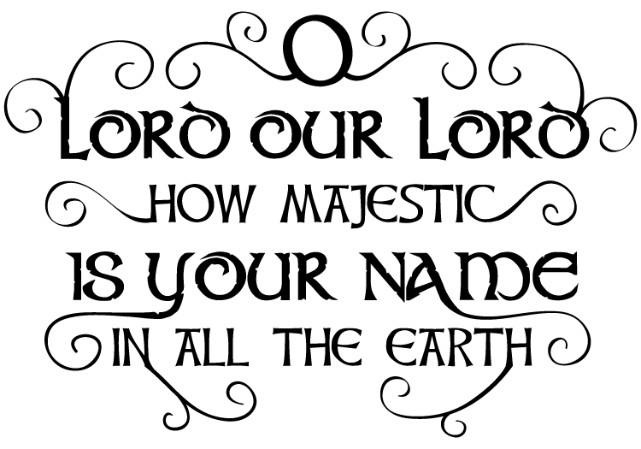
Acknowledgements
- Divine Service I music is © 2002 Kermit Moldenhauer.
- All copyrighted materials reprinted under OneLicense.net # A-712592.
- If Your Beloved Son, O God Setting: © 1993 Kermit G. Moldenhauer. Used by permission.
- Voices Raised to You We Offer Text: Herman G. Stuempfle Jr. © 1997 GIA Publications, Inc. All rights reserved. Used by permission. Tune & setting: Carolyn Jennings © 1996. All rights reserved. Used by permission.
- The introductory image is from Christian Worship Supplement ©2008, Northwestern Publishing House. All other images are from Paramentics.com, done by Ian Welch © 2013. For all images: All rights reserved. Used by permission.

This creed is named after St. Athanasius (ca. 296-373), a staunch defender of the Christian faith in the fourth century. It was prepared to assist the Church in combating two errors that undermined Bible teaching. One error denied that God's Son and the Holy Spirit are of one being or Godhead with the Father. The other error denied that Jesus Christ is true God and true man in one person. The Athanasian Creed continues to serve the Christian Church as a standard of the truth. It is normally read on Trinity Sunday as a statement that the only true God is the Triune God who saves us through faith in the atoning sacrifice of Jesus Christ. This statement of faith and historical introduction is also found on Christian Worship, pages 132-133

