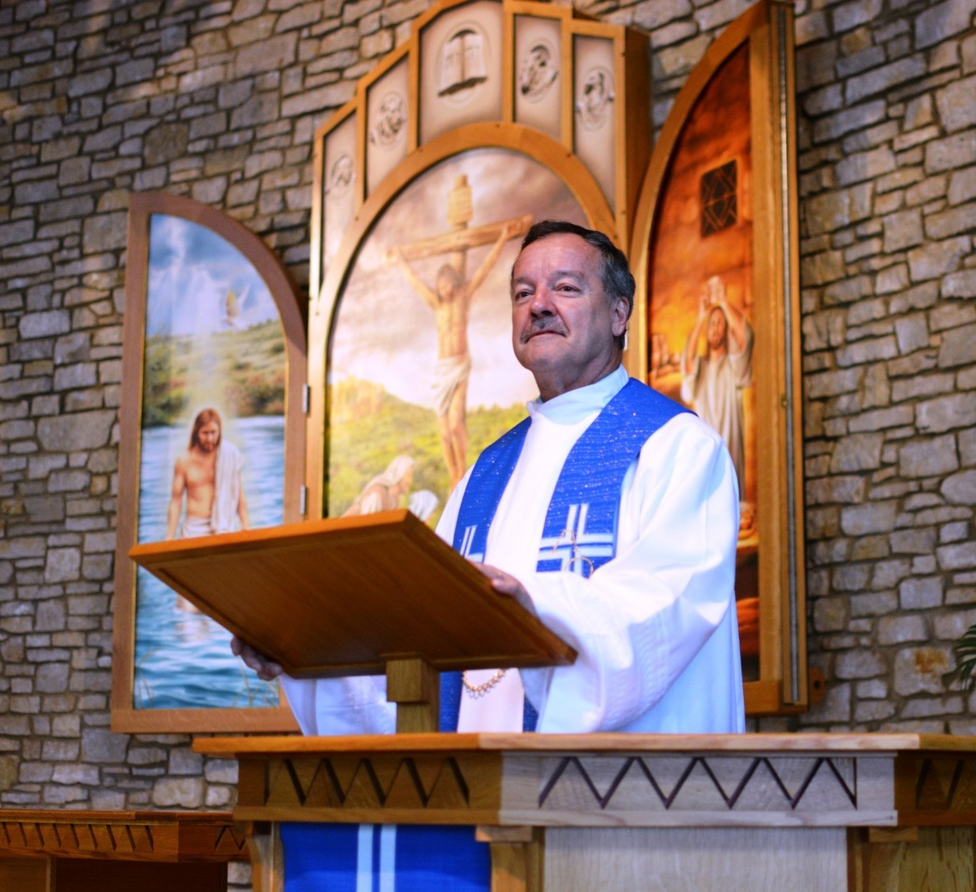

The 2nd Sunday after Pentecost

Preaching Christ Crucified

June 20 and 23, 2019

In the name of our Lord Jesus, welcome! We pray that within our church you will find the quiet assurance of God’s presence, the warmth of Christian fellowship, and the abiding truth of God’s Word. Come worship with us again!

FOR VISITORS___________________________________________
• Visitor Cards: If this is your first visit to Zion, welcome! Please fill out a blue visitor card. You will find them in the pew racks and on the media counter in the lobby.
• Restrooms: The main restrooms are located just off the lobby. A family restroom is located down the hall from the library.
• Parents: You may use the library, lobby or fellowship hall for nursing or other childcare. Changing stations are provided in all restrooms.
• Sound: Hearing assistance is available for your use. Both the sanctuary and fellowship hall are equipped with hearing loops. Please set your hearing aid to the T (telecoil) setting. Portable audio receivers are also available from the ushers.
• Information: The media counter is located in the entryway. Here you will find magazines, brochures, devotional booklets, children’s bulletins, and more.
• Contact: Our pastors and principal are here to serve you. Contact information is provided below.

SERVING TODAY___________________________________________
Preaching Pastor Robert Wilke
Presiding Pastor Timothy Schwartz
Organist Kris Kehl
Ushers (8:00) Mark Lindell, Remington Lindell, Andy Tratar, Andrew Bussian,
Matt Yaroch, Nick Yaroch
Ushers (10:30) Otto Mattke, Paul Kehl, Dennis Winter, Carl Wolf, William Mattke, Nils Johansson
Greeters (8:00) Dave & Kathy Harle
Greeters (10:30) Otto & Sheree Mattke
Video Randy Koehn

CONTACT US___________________________________________
Website zioncolumbus.org
Office Phone 920-623-5180
Office Email office@zioncrusaders.com
Church Address 812 Western Avenue
School Address 822 Western Avenue
Pastor Robert Wilke 920-623-4870; revrwilke@gmail.com
Pastor Tim Schwartz 509-480-2967; tschwartz24@gmail.com
Principal Alex Vandenberg 507-353-0719; avandenberg@zioncrusaders.com

DIVINE SERVICE II (adapted)

OPENING HYMN The Church’s One Foundation | CW 538

INVOCATION
Minister: In the name of the Father and of the Son and of the Holy Spirit.
Congregation: Amen.

CONFESSION
M: Dear friends, let us approach God with a true heart and confess our sins, asking him in the name of our Lord Jesus Christ to forgive us.
C: Lord of life, I confess that I am by nature dead in sin.
For faithless worrying and selfish pride,
For sins of habit and sins of choice,
For the evil I have done and the good I have failed to do,
You should cast me away from your presence forever.
O Lord, I am sorry for my sins. Forgive me, for Jesus’ sake.

ABSOLUTION
M: Christ has died. Christ is risen. Christ will come again. In his great mercy, God made us alive in Christ even when we were dead in our sins. Hear the word of Christ through his called servant: I forgive you all your sins in the name of the Father and of the Son (†) and of the Holy Spirit.
C: Amen.

LORD, HAVE MERCY |Kyrie Mark 10:47
M: In peace, let us pray to the Lord. For the well-being of all people everywhere, that they may receive from you all they need to sustain body and life, hear our prayer, O Lord.
C: Lord, have mercy.
M: For the spread of your life-giving gospel throughout the world, that all who are lost in sin may be brought to faith in you, hear our prayer, O Christ.
C: Christ, have mercy.
M: For patience and perseverance in this life, that we may not lose the hope of heaven as we await your return, hear our prayer, O Lord.
C: Lord, have mercy.
M: Lord of life, live in us that we may live for you.
C: Amen.
SONG by Mr. Buege (Zion Principal from 1984-1994) The Lord is My Light | CWS 767
Refrain: The Lord is my light and my salvation.
The Lord is the stronghold of my life.
Since the Lord is my life, my strength, and my all,
Whom then shall I fear?

There is one thing I ask of the Lord:
To dwell in his house forever,
To gaze on the beauty of the Lord
All the days of my life.
Refrain.

Teach me, Lord, and keep me on your paths;
Guide me, Lord, along a level way.
I will gaze on the goodness of the Lord
In the land of the living.
Refrain.

THE WORD

SALUTATION
M: The Lord be with you.
C: And also with you.

PRAYER OF THE DAY
M: Let us pray. Almighty God, you have always given your Church faithful shepherds to feed and watch over your flock. Grant that all pastors may rightly preach your Word and administer your sacraments that your people may be guided in the way that leads to eternal life: through Jesus Christ, who lives and reigns with you and the Holy Spirit, one God, now and forever.
C: Amen.

OLD TESTAMENT LESSON Isaiah 6:1-6 | NIV
I
n the year that King Uzziah died, I saw the Lord, high and exalted, seated on a throne; and the train of his robe filled the temple. ² Above him were seraphim, each with six wings: With two wings they covered their faces, with two they covered their feet, and with two they were flying. ³ And they were calling to one another:
“Holy, holy, holy is the Lord Almighty;
the whole earth is full of his glory.”
⁴ At the sound of their voices the doorposts and thresholds shook and the temple was filled with smoke.
⁵ “Woe to me!” I cried. “I am ruined! For I am a man of unclean lips, and I live among a people of unclean lips, and my eyes have seen the King, the Lord Almighty.”
⁶ Then one of the seraphim flew to me with a live coal in his hand, which he had taken with tongs from the altar.

VERSE OF THE DAY

SECOND LESSON John 2:13-22 | NIV
I
thank God, whom I serve, as my ancestors did, with a clear conscience, as night and day I constantly remember you in my prayers. ⁴ Recalling your tears, I long to see you, so that I may be filled with joy. ⁵ I am reminded of your sincere faith, which first lived in your grandmother Lois and in your mother Eunice and, I am persuaded, now lives in you also.
⁶ For this reason I remind you to fan into flame the gift of God, which is in you through the laying on of my hands. ⁷ For the Spirit God gave us does not make us timid, but gives us power, love and self-discipline. ⁸ So do not be ashamed of the testimony about our Lord or of me his prisoner. Rather, join with me in suffering for the gospel, by the power of God. ⁹ He has saved us and called us to a holy life—not because of anything we have done but because of his own purpose and grace. This grace was given us in Christ Jesus before the beginning of time, ¹⁰ but it has now been revealed through the appearing of our Savior, Christ Jesus, who has destroyed death and has brought life and immortality to light through the gospel. ¹¹ And of this gospel I was appointed a herald and an apostle and a teacher. ¹² That is why I am suffering as I am. Yet this is no cause for shame, because I know whom I have believed, and am convinced that he is able to guard what I have entrusted to him until that day.
SONG by Mike Armstrong (Zion Confirmation Class of 1976) All the Way My Savior Leads Me Text: Fanny J. Crosby. Music: Robert Lowery. Arrangement: Rich Mullins (Phil. 1:6; 3:10-15)

All the way my Savior leads me
What have I to ask beside?
Can I doubt His faithful mercies?
Who through life has been my guide
Heavenly peace, divinest comfort
Ere by faith in Him to dwell
For I know whate'er befall me
Jesus doeth all things well

All of the way my Savior leads me
And He cheers each winding path I tread
Gives me strength for every trial
And He feeds me with the living bread
And though my weary steps may falter
And my soul a-thirst may be
Gushing from a rock before me
Though a spirit joy I see

And all the way my Savior leads me
Oh, the fullness of His love
Perfect rest in me is promised
In my Father's house above
When my spirit clothed immortal
Wings its flight through the realms of the day
This my song through endless ages
Jesus led me all the way

M: The Gospel according to John, chapter 21.
C: Glory be to you, O Lord.

GOSPEL LESSON John 21:15-17 | NIV
W
hen they had finished eating, Jesus said to Simon Peter, “Simon son of John, do you love me more than these?”
“Yes, Lord,” he said, “you know that I love you.”
Jesus said, “Feed my lambs.”
¹⁶ Again Jesus said, “Simon son of John, do you love me?”
He answered, “Yes, Lord, you know that I love you.”
Jesus said, “Take care of my sheep.”
¹⁷ The third time he said to him, “Simon son of John, do you love me?”
Peter was hurt because Jesus asked him the third time, “Do you love me?” He said, “Lord, you know all things; you know that I love you.”
Jesus said, “Feed my sheep.

M: This is the Gospel of the Lord.
C: Praise be to you, O Christ.
HYMN OF THE DAY Chief of Sinners Though I Be | CW 385

SERMON By the Grace of God I Have Preached Christ Crucified | I Corinthians 2:1-2 | NIV
When I came to you, I did not come with eloquence or human wisdom as I proclaimed to you the testimony about God. ² For I resolved to know nothing while I was with you except Jesus Christ and him crucified.

APOSTLES’ CREED
I believe in God, the Father almighty, maker of heaven and earth.
I believe in Jesus Christ, his only Son, our Lord, who was conceived by the Holy Spirit, born of the virgin Mary, suffered under Pontius Pilate, was crucified, died, and was buried. He descended into hell. The third day he rose again from the dead. He ascended into heaven and is seated at the right hand of God the Father almighty. From there he will come to judge the living and the dead.
I believe in the Holy Spirit, the holy Christian Church, the communion of saints, the forgiveness of sins, the resurrection of the body, and the life everlasting. Amen.

OFFERING

OFFERING PRAYER
M: The gift of your Son as a Savior for us sinners is the ultimate act of generosity and grace. With hearts touched by your grace, let us take after you as we bring our offerings to you. May the hearts with which we give be generous hearts. Let the preaching of your gospel that these offerings support make more and more rich in faith, hope and love.
C: Amen.

PRAYER OF THE CHURCH for the MISSION OF THE CHURCH
M: Eternal God and Father, we give you thanks for the blessings we share as members of your holy Church, for your gracious Word and sacraments, for opportunities to worship and to grow in faith and knowledge, for occasions to serve and be served, for fellowship with believers in our congregation and in our synod.
C: Help us to rejoice in these blessings, dear Lord, and to use them faithfully.

M: Jesus Christ, Lord of the Church, you give grace to your people by calling us to be your witnesses in the world. Open our eyes to see the great and noble mission that lies before us. In the hurting eyes of the lonely, in the pained eyes of the sick, and in the searching eyes of the lost, help us to see your face, O Jesus, and to serve others as we would serve you.
C: Awaken us to the opportunities you give to proclaim your message of love.
M: Holy Spirit, giver of life, through Word and sacrament bestow on us the wisdom and power we need to witness clearly and to act boldly. Help us to speak the truth in love, to give the reason for the hope we have, and to conduct ourselves with gentleness and respect.
C: Set our hearts on fire as we work and witness for Christ.
M: Hear us, Lord, as we pray for a family member, an acquaintance, a neighbor, or a friend who does not believe in you, or whose faith is weak or troubled.
Silent prayer.
Bless the Church with men and women who are willing to proclaim your Word in places where we cannot go. Keep them and their loved ones in your care, and let nothing hinder their work. By the power of the gospel, restore their spirits each day, so that they do not lose heart as they serve us and others.
C: Move us to support them with our sincere prayers and generous offerings.
Special prayers and intercessions may follow.
M: Wherever your Word is proclaimed, O Lord, grant it success. Let your kingdom come to us and others, so that we and many more might join the assembly of saints and angels to sing your praise forever.
C: Savior of all, hear our prayer and help us in our mission. Amen.

LORD’S PRAYER Matthew 6:9-13
C: Our Father in heaven, hallowed be your name, your kingdom come, your will be done on earth as in heaven. Give us today our daily bread. Forgive us our sins, as we forgive those who sin against us. Lead us not into temptation, but deliver us from evil. For the kingdom, the power, and the glory are yours now and forever. Amen.

HYMN By Grace I’m Saved | CW 384

PRAYER
M: Lord of the harvest, inspire the hearts of many to offer themselves for the public ministry of your church. Look with favor on our schools, blessing those who teach and those who learn that they may apply themselves diligently to your will and faithfully to your service; through Jesus Christ, our Lord.
C: Amen.

BLESSING
M: The Lord bless you and keep you.
The Lord make his face shine on you and be gracious to you.
The Lord look on you with favor and (†) give you peace.
C: Amen.

RITE OF FAREWELL | 10:30 Service Only
M: Dear brothers and sisters in Christ, Pastor Robert Wilke is retiring from his pastorate at this congregation. As we bid him farewell, we look to the Word of our Lord for comfort, peace, and guidance.
Glorify the Lord with me; let us exalt his name together. Know that the Lord is God.
C: It is he who made us, and we are his; we are his people, the sheep of his pasture.
M: Enter his gates with thanksgiving and his courts with praise; give thanks to him and praise his name.
C: For the Lord is good and his love endures forever; his faithfulness continues through all generations.
M: O Lord Almighty, blessed are those who dwell in your house.
C: O Lord Almighty, blessed is the man who trusts in you.
M: Blessed is the man who does not walk in the counsel of the wicked or stand in the way of sinners or sit in the seat of mockers.
C: His delight is in the law of the Lord, and on his law he meditates day and night.
M: He is like a tree planted by streams of water, which yields its fruit in season and whose leaf does not wither. Whatever he does prospers.
C: Glory be to the Father and to the Son and to the Holy Spirit; as it was in the beginning, is now, and will be forever. Amen.
M: Let us pray.
Lord God, heavenly Father, we give thanks for all the blessings you have given this congregation through the ministry of your servant Pastor Wilke. By your Holy Spirit give him grace, that by his example of faithful devotion to your Word, he may be a blessing to many. In your mercy support and strengthen him in his life, and grant him peace and blessedness now and forever, through your Son, our Great High Priest, Jesus Christ our Lord.
C: Amen.

BLESSING | 10:30
M: Dear brother in Christ, the Lord will keep you from all harm; he will watch over your life.
The Lord will watch over your coming and going both now and forever.
C: Amen.

CLOSING HYMN Lift High the Cross | CW 579

Please remain seated following the closing hymn for a few remarks. A luncheon is planned afterword in the Zion school gymnasium. Everyone is welcome to join us for food and an opportunity to greet Pastor and Mrs. Wilke at that time.

Acknowledgments
- Divine Service II -2004 Northwestern Publishing House.
- General Verse © 2005 Dale Witte. Dale Witte. Reprinted by permission. All rights reserved.
- The Lord is My Light Text: Alberto Taule, tr. Lorraine Florindez, tr. Jon D. Vicker © 2006 Jon D. Vicker. All rights reserved. Used by permission. Tune: Alberto Taule © 1982 Published by OCP Publications, 5536 NE Hassalo, Portland, OR 97213. All rights reserved. Used with permission. Setting: Amanda Husberg Alberto Taule © 1982 Published by OCP Publications, 5536 NE Hassalo, Portland, OR 97213. All rights reserved. Used with permission.
- Chief of Sinners, Though I Be Setting: © 1993 Kermit G. Moldenhauer. Used by permission.
- Lift High the Cross Text, tune, setting: © 1974 by Hope Publishing Co., Carol Stream, IL 60188. All rights reserved. Used by permission.
- All copyrighted materials reprinted under OneLicense.net # A-712592.
- The introductory image is from Christian Worship Supplement ©2008, Northwestern Publishing House. All other images are from Paramentics.com, done by Ian Welch © 2013. For all images: All rights reserved. Used by permission.

