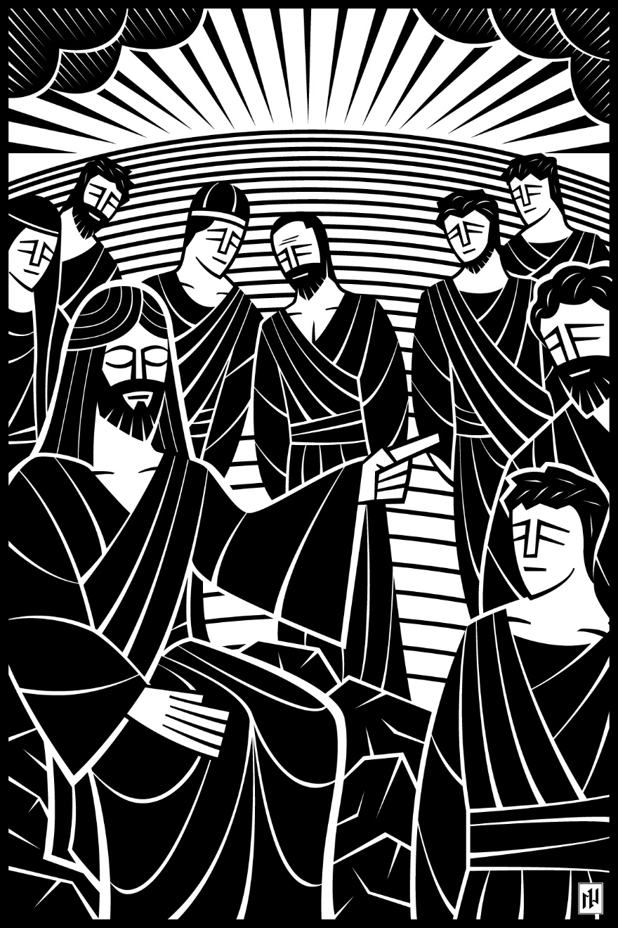
7th Sunday after Pentecost
The Believer Follows God…Trusting Him to Supply Our Needs
July 25 and 28, 2019
In the name of our Lord Jesus, welcome! We pray that within our church you will find the quiet assurance of God’s presence, the warmth of Christian fellowship, and the abiding truth of God’s Word. Come worship with us again!

FOR VISITORS___________________________________________
• Visitor Cards: If this is your first visit to Zion, welcome! Please fill out a blue visitor card. You will find them in the pew racks and on the media counter in the lobby.
• Restrooms: The main restrooms are located just off the lobby. A family restroom is located down the hall from the library.
• Parents: You may use the library, lobby or fellowship hall for nursing or other childcare. Changing stations are provided in all restrooms.
• Sound: Hearing assistance is available for your use. Both the sanctuary and fellowship hall are equipped with hearing loops. Please set your hearing aid to the T (telecoil) setting. Portable audio receivers are also available from the ushers.
• Information: The media counter is located in the entryway. Here you will find magazines, brochures, devotional booklets, children’s bulletins, and more.
• Contact: Our pastors and principal are here to serve you. Contact information is provided below.

SERVING TODAY___________________________________________
Preaching & Presiding Pastor Timothy Schwartz
Organist Marie Becker
Ushers (8:00) Jim Greiling, Matt Greiling, Mike Sommer, John Brey, Bob Marousek
Ushers (10:30) Tom Schultz, George Decker, Aaron Larson, James Kopfer, Dayne Kopfer
Brandon Lee, Brian Vierck
Communion Assistant (8:00) Leo Fischer
Communion Assistant (10:30) Mike Hallberg
Greeters (8:00) Wilma Lenz and Joan Herzberg
Greeters (10:30) Janell Allar and Kay Salzwedel
Video Phil Manteufel

CONTACT US___________________________________________
Website zioncolumbus.org
Office Phone 920-623-5180
Office Email office@zioncrusaders.com
Church Address 812 Western Avenue
School Address 822 Western Avenue
Pastor Tim Schwartz 509-480-2967; tschwartz24@gmail.com
Principal Alex Vandenberg 507-353-0719; avandenberg@zioncrusaders.com

DIVINE SERVICE II

OPENING HYMN Praise to the Lord, the Almighty | CW 234, v. 1-3

INVOCATION
Minister: In the name of the Father and of the Son and of the Holy Spirit.
Congregation: Amen.

CONFESSION
M: Our Savior Jesus Christ commanded baptism when he said: “Go and make disciples of all nations, baptizing them in the name of the Father and of the Son and of the Holy Spirit.” All of us are born into this world with a deep need for baptism. From our parents we inherit a sinful nature; we are without true fear of God and true faith in God and are condemned to eternal death. But Jesus took away our sin by giving his life on the cross. At our baptism he clothes us with the robe of his righteousness and gives us a new life. Our sinful nature need not control us any longer. We recall what baptism means for our daily lives as we speak these words:
C: Baptism means that the sinful nature in us should be drowned by daily sorrow and repentance, and that all its evil deeds and desires be put to death. It also means that a new person should daily arise to live before God in righteousness and purity forever.

M: As baptized children of God we confess our sins:
C: Holy and merciful Father, I confess that I am by nature sinful, and that I have disobeyed you in my thoughts, words, and actions. I have done what is evil and failed to do what is good. For this I deserve your punishment both now and in eternity. But I am truly sorry for my sins, and trusting in my Savior Jesus Christ, I pray: Lord, have mercy on me a sinner.

ABSOLUTION
M: God, our heavenly Father, has been merciful to us and has given his only Son to be the atoning sacrifice for our sins. Therefore, as a called servant of Christ and by his authority, I forgive you all your sins in the name of the Father and of the Son and of the Holy Spirit.
C: Amen.

AFFIRMATION OF HOLY BAPTISM | 10:30
LORD, HAVE MERCY |Kyrie Mark 10:47
M: In peace, let us pray to the Lord. For the well-being of all people everywhere, that they may receive from you all they need to sustain body and life, hear our prayer, O Lord.
C: Lord, have mercy.
M: For the spread of your life-giving gospel throughout the world, that all who are lost in sin may be brought to faith in you, hear our prayer, O Christ.
C: Christ, have mercy.
M: For patience and perseverance in this life, that we may not lose the hope of heaven as we await your return, hear our prayer, O Lord.
C: Lord, have mercy.
M: Lord of life, live in us that we may live for you.
C: Amen.

HYMN CW 234, v. 4,5
4. Praise to the Lord, who will prosper your work and defend you;
Surely his goodness and mercy shall daily attend you.
Ponder anew What the Almighty can do
As with his love he befriends you.

5. Praise to the Lord! Oh, let all that is in me adore him!
All that has life and breath, come now with praises before him!
Let the Amen Sound from his people again;
Gladly forever adore him!

THE WORD
SALUTATION
M: The Lord be with you.
C: And also with you.

PRAYER OF THE DAY
M: God of all power and might, you are the giver of all that is good. Help us love you with all our heart. Strengthen us in true faith. Provide us with all we need. Keep us safe in your care; through Jesus Christ, your Son, our Lord, who lives and reigns with you and the Holy Spirit, one God, now and forever.
C: Amen.
OLD TESTAMENT LESSON I Kings 17:1-16 | NIV
N
ow Elijah the Tishbite, from Tishbe in Gilead, said to Ahab, “As the Lord, the God of Israel, lives, whom I serve, there will be neither dew nor rain in the next few years except at my word.”
² Then the word of the Lord came to Elijah: ³ “Leave here, turn eastward and hide in the Kerith Ravine, east of the Jordan. ⁴ You will drink from the brook, and I have directed the ravens to supply you with food there.”
⁵ So he did what the Lord had told him. He went to the Kerith Ravine, east of the Jordan, and stayed there. ⁶ The ravens brought him bread and meat in the morning and bread and meat in the evening, and he drank from the brook.
⁷ Some time later the brook dried up because there had been no rain in the land. ⁸ Then the word of the Lord came to him: ⁹ “Go at once to Zarephath in the region of Sidon and stay there. I have directed a widow there to supply you with food.” ¹⁰ So he went to Zarephath. When he came to the town gate, a widow was there gathering sticks. He called to her and asked, “Would you bring me a little water in a jar so I may have a drink?” ¹¹ As she was going to get it, he called, “And bring me, please, a piece of bread.”
¹² “As surely as the Lord your God lives,” she replied, “I don’t have any bread—only a handful of flour in a jar and a little olive oil in a jug. I am gathering a few sticks to take home and make a meal for myself and my son, that we may eat it—and die.”
¹³ Elijah said to her, “Don’t be afraid. Go home and do as you have said. But first make a small loaf of bread for me from what you have and bring it to me, and then make something for yourself and your son. ¹⁴ For this is what the Lord, the God of Israel, says: ‘The jar of flour will not be used up and the jug of oil will not run dry until the day the Lord sends rain on the land.’ ”
¹⁵ She went away and did as Elijah had told her. So there was food every day for Elijah and for the woman and her family. ¹⁶ For the jar of flour was not used up and the jug of oil did not run dry, in keeping with the word of the Lord spoken by Elijah.

VERSE OF THE DAY
M: The Gospel according to Luke, chapter 10.
C: Glory be to you, O Lord.

GOSPEL LESSON Luke 10:1-12, 16-20 | NIV
A
fter this the Lord appointed seventy-two others and sent them two by two ahead of him to every town and place where he was about to go. ² He told them, “The harvest is plentiful, but the workers are few. Ask the Lord of the harvest, therefore, to send out workers into his harvest field. ³ Go! I am sending you out like lambs among wolves. ⁴ Do not take a purse or bag or sandals; and do not greet anyone on the road.
⁵ “When you enter a house, first say, ‘Peace to this house.’ ⁶ If someone who promotes peace is there, your peace will rest on them; if not, it will return to you. ⁷ Stay there, eating and drinking whatever they give you, for the worker deserves his wages. Do not move around from house to house.
⁸ “When you enter a town and are welcomed, eat what is offered to you. ⁹ Heal the sick who are there and tell them, ‘The kingdom of God has come near to you.’ ¹⁰ But when you enter a town and are not welcomed, go into its streets and say, ¹¹ ‘Even the dust of your town we wipe from our feet as a warning to you. Yet be sure of this: The kingdom of God has come near.’ ¹² I tell you, it will be more bearable on that day for Sodom than for that town.

¹⁶ “Whoever listens to you listens to me; whoever rejects you rejects me; but whoever rejects me rejects him who sent me.”
¹⁷ The seventy-two returned with joy and said, “Lord, even the demons submit to us in your name.”
¹⁸ He replied, “I saw Satan fall like lightning from heaven. ¹⁹ I have given you authority to trample on snakes and scorpions and to overcome all the power of the enemy; nothing will harm you. ²⁰ However, do not rejoice that the spirits submit to you, but rejoice that your names are written in heaven.”

M: This is the Gospel of the Lord.
C: Praise be to you, O Christ.

HYMN OF THE DAY When Jesus Came from Nazareth | CWS 772

LESSON Philippians 4:10-20| NIV
I
rejoiced greatly in the Lord that at last you renewed your concern for me. Indeed, you were concerned, but you had no opportunity to show it. ¹¹ I am not saying this because I am in need, for I have learned to be content whatever the circumstances. ¹² I know what it is to be in need, and I know what it is to have plenty. I have learned the secret of being content in any and every situation, whether well fed or hungry, whether living in plenty or in want. ¹³ I can do all this through him who gives me strength.
¹⁴ Yet it was good of you to share in my troubles. ¹⁵ Moreover, as you Philippians know, in the early days of your acquaintance with the gospel, when I set out from Macedonia, not one church shared with me in the matter of giving and receiving, except you only; ¹⁶ for even when I was in Thessalonica, you sent me aid more than once when I was in need. ¹⁷ Not that I desire your gifts; what I desire is that more be credited to your account. ¹⁸ I have received full payment and have more than enough. I am amply supplied, now that I have received from Epaphroditus the gifts you sent. They are a fragrant offering, an acceptable sacrifice, pleasing to God. ¹⁹ And my God will meet all your needs according to the riches of his glory in Christ Jesus.
²⁰ To our God and Father be glory for ever and ever. Amen.

SERMON My God Will Supply Your Every Need | Philippians 4:10-20 | NIV

NICENE CREED
We believe in one God, the Father, the Almighty, maker of heaven and earth, of all that is, seen and unseen.
We believe in one Lord, Jesus Christ, the only Son of God, eternally begotten of the Father, God from God, Light from Light, true God from true God, begotten, not made, of one being with the Father. Through him all things were made. For us and for our salvation, he came down from heaven, was incarnate of the Holy Spirit and the virgin Mary, and became fully human. For our sake he was crucified under Pontius Pilate. He suffered death and was buried. On the third day he rose again in accordance with the Scriptures. He ascended into heaven and is seated at the right hand of the Father. He will come again in glory to judge the living and the dead, and his kingdom will have no end.
We believe in the Holy Spirit, the Lord, the giver of life, who proceeds from the Father and the Son, who in unity with the Father and the Son is worshiped and glorified, who has spoken through the prophets. We believe in one holy Christian and apostolic Church. We acknowledge one baptism for the forgiveness of sins. We look for the resurrection of the dead and the life of the world to come. Amen.

OFFERING

OFFERING PRAYER
M: Lord God, grant us a generous spirit, endowed with the gifts of the Holy Spirit, that we may not withhold out of fear but give joyfully and with thanksgiving to the Lord and for the support of His work.
C: Amen.

PRAYER OF THE CHURCH
M: Let us pray for the whole people of God in Christ Jesus and for all people as they have need.
Brief silence
For the faithful preaching and teaching of the Gospel, that we may not be caught up in the wisdom of the world and so depart from the eternal truth of Christ crucified, let us pray to the Lord:
C: Lord, have mercy.
M: For Christ’s Holy Church here and throughout the world, for all who hear the Word of God and are brought to repentance and faith, and for grace that God’s people may be kept from error and sustained in the Word of God even in persecution, let us pray to the Lord:
C: Lord, have mercy.
M: For this congregation; for the work of God’s kingdom that goes out from here as we worship; and for those who serve us in Christ’s name here and throughout the world, let us pray to the Lord:
C: Lord, have mercy.
M: For a faithful and fruitful life of prayer, let us pray to the Lord:
C: Lord, have mercy.
M: For all who commune this day, that they may receive in faith and for their benefit the precious body and blood of our Savior and keep this blessed communion with faithful lives all their days, let us pray to the Lord:
C: Lord, have mercy.
M: For the government of our country, for the elected and appointed leaders of our nation, for godly lives as citizens, and for those who protect and defend our country both here and abroad, let us pray to the Lord:
C: Lord, have mercy.
M: For honest labor, for all worthy occupations, and for the culture and enrichment of the arts in service to God, let us pray to the Lord:
C: Lord, have mercy.
Requested Prayers
M: For a long memory of the mercies God has shown to us and for a short memory of those who have wronged us, that our bitterness may give way to love and peace, let us pray to the Lord:
C: Lord, have mercy.
M: Help, save, comfort and defend us, gracious Lord. O Lord, bring us at last through all trials and deliver us into your Kingdom without end; through Jesus Christ, our Lord.
C: Amen.
THE SACRAMENT
M: The Lord be with you.
C: And also with you.
M: Lift up your hearts.
C: We lift them up to the Lord.
M: Let us give thanks to the Lord our God.
C: It is good and right so to do.
M: It is truly good and right that we should at all times and in all places
C: give you thanks, O Lord, holy Father,
M: almighty and everlasting God,
C: through Jesus Christ, our Lord,
M: who has called us to be his own so that we may live under him in his kingdom
C: and serve him in everlasting righteousness, innocence, and blessedness.
M: Therefore with all the saints on earth and hosts of heaven,
C: we praise your holy name and join their glorious song:

HOLY, HOLY, HOLY | Sanctus Isaiah 6:3; Matthew 21:9
Sung to the tune of O Lord, How Shall I Meet You | CW 19
C: O holy, holy, holy
Lord God of pow’r and might,
Your glory, earth and heaven
In countless ways recite.
Hosanna! Come and save us,
Lord God of hosts on high,
And in your grace and mercy
Receive our fervent cry.
Hosanna in the highest!
How truly blest is he
Who in God’s name is coming
To set his people free!
He comes to bring salvation
And with his blood outpoured,
Deliver us from bondage—
Hosanna, mighty Lord!
PRAYER OF THANKSGIVING
M: Blessed are you, O Lord, because you have brought us from death to life.
C: With humble and repentant hearts, we praise and thank you for your Son, Jesus Christ.
M: He became our substitute under your holy law,
C: He destroyed the works of the devil by his perfect obedience to your will,
M: He willingly carried a cross to pay the debt of the world’s sin,
C: He lives and reigns to give us life.
M: Through his body and blood, once given and poured out for us,
C: forgive our sins and strengthen us for our journey heavenward.
M: Unite us to our crucified and risen Lord,
C: that we may believe in him,
M: that we may confess him,
C: that we may call on his name,
M: and finally be delivered from this world to the feast of the Lamb,
C: whose kingdom has no end. Amen.

LORD’S PRAYER Matthew 6:9-13
C: Our Father in heaven, hallowed be your name, your kingdom come, your will be done on earth as in heaven. Give us today our daily bread. Forgive us our sins, as we forgive those who sin against us. Lead us not into temptation, but deliver us from evil. For the kingdom, the power, and the glory are yours now and forever. Amen.

WORDS OF INSTITUTION Matthew 26:26-28; 1Corinthians 11:24.25
M: Our Lord Jesus Christ, on the night he was betrayed, took bread; and when he had given thanks, he broke it and gave it to his disciples, saying, “Take and eat; this is my (†) body, which is given for you. Do this in remembrance of me.”
Then he took the cup, gave thanks, and gave it to them, saying, “Drink from it, all of you; this is my (†) blood of the new covenant, which is poured out for you for the forgiveness of sins. Do this, whenever you drink it, in remembrance of me.”
The peace of the Lord be with you always.
C: Amen.

LAMB OF GOD | Agnus Dei John 1:29

COMMUNING AT ZION
Communion: If you are visiting today we ask you to speak to one of our pastors before communing. We follow the Biblical, ancient custom of close communion (also called “member communion”).
Confession: Receiving Holy Communion is a statement of faith. Any person who takes communion with a group of believers is publicly saying, “I believe everything this church teaches.”
Instruction: In order for people to understand the teachings that they are confessing when they take communion, we offer classes on the Christian faith in our church (and all of our WELS and ELS churches). We ask all visitors who have not yet received such instruction to first go through the classes before taking part in the Lord’s Supper.

DISTRIBUTION

DISTRIBUTION HYMNS I Lay My Sins on Jesus | CW 372
Jesus, Your Blood and Righteousness | CW 376

SONG OF SIMEON Luke 2:29-32
Sung to the tune of Today Your Mercy Calls Us | CW 339

O Lord, now let your servant
Depart in peace, assured:
For I have seen your promised
incarnate, saving Word—
A Light that will enlighten
All gloom where Gentiles dwell;
The brilliant, crowning glory
Of those in Israel!

All glory to the Father,
All glory to the Son,
All glory to the Spirit,
Forever three in one;
For as in the beginning,
Is now, shall ever be,
God’s triune name resounding
Through all eternity.

M: We give you thanks, O Lord, for the foretaste of the heavenly banquet that you have given us to eat and to drink in this sacrament. Through this gift you have fed our faith, nourished our hope, and strengthened our love. By your Spirit help us to live as your holy people until that day when you will receive us as your guests at the wedding supper of the Lamb, who lives and reigns with you and the Holy Spirit, one God, now and forever.
C: Amen.

BLESSING Numbers 6:24-26
M: The Lord bless you and keep you.
The Lord make his face shine on you and be gracious to you.
The Lord look on you with favor and (†) give you peace.
C: Amen.

CLOSING HYMN My Shepherd Will Supply My Need | CW 374

Acknowledgments
- Divine Service II -2004 Northwestern Publishing House.
- General Verse © 2005 Dale Witte. Lamb of God ©2005 Dale Witte. Reprinted by permission. All rights reserved.
- All copyrighted materials reprinted under OneLicense.net # A-712592.
- My Shepherd Will Supply My Need Setting: © 1993 Kermit G. Moldenhauer. Used by permission.
- When Jesus Came From Nazareth Text (st 1-4): Herman G. Stuempfle © 2000 GIA Publications, Inc. All rights reserved. Used by permission. Text (st 5): Michael Schultz. All rights reserved. Used by permission. Tune, setting: Randall Sensmeier © 1999 GIA Publications, Inc. All rights reserved. Used by permission.
- The introductory image is from Christian Worship Supplement ©2008, Northwestern Publishing House. All other images are from Paramentics.com, done by Ian Welch © 2013. For all images: All rights reserved. Used by permission.

