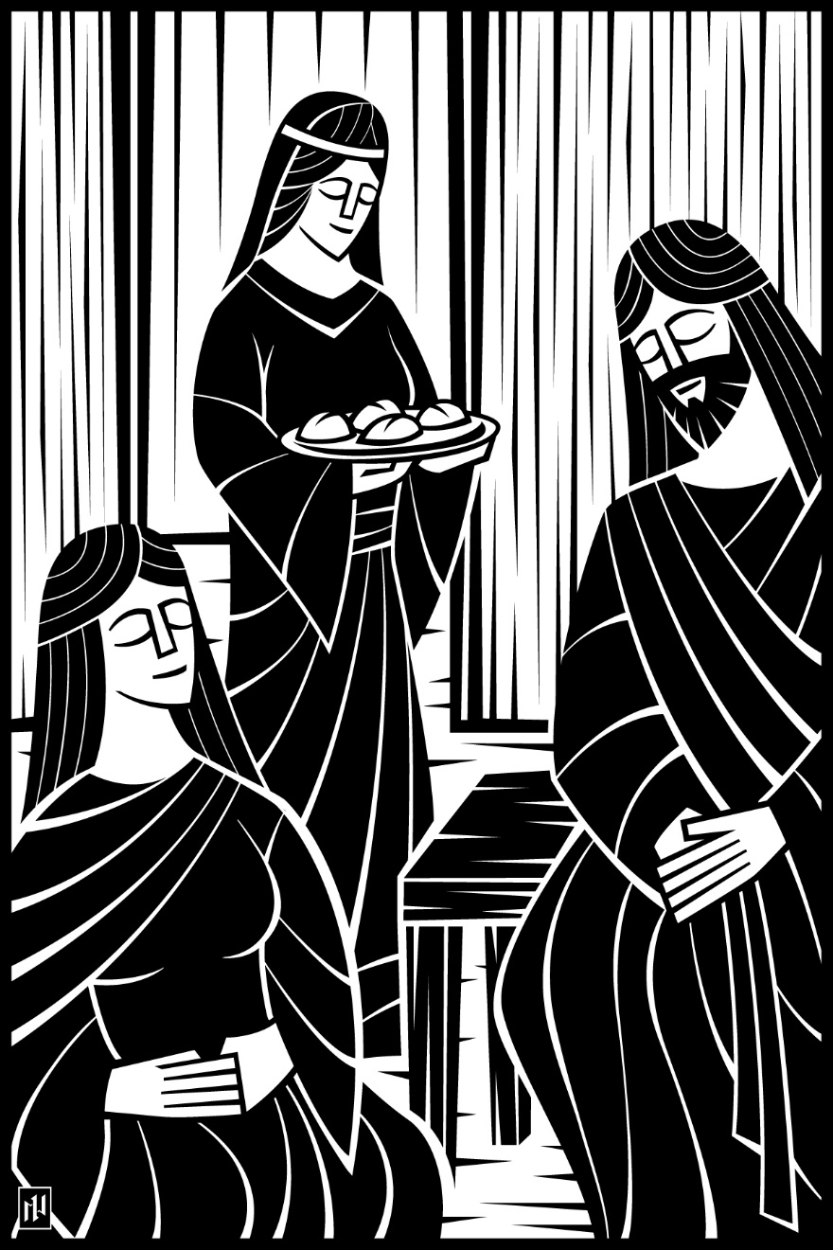
9th Sunday after Pentecost
The Believer Follows God…with a Heart that Always Trusts God’s Word
August 8 and 11, 2019

In the name of our Lord Jesus, welcome! We pray that within our church you will find the quiet assurance of God’s presence, the warmth of Christian fellowship, and the abiding truth of God’s Word. Come worship with us again!

FOR VISITORS___________________________________________
• Visitor Cards: If this is your first visit to Zion, welcome! Please fill out a blue visitor card. You will find them in the pew racks and on the media counter in the lobby.
• Restrooms: The main restrooms are located just off the lobby. A family restroom is located down the hall from the library.
• Parents: You may use the library, lobby or fellowship hall for nursing or other childcare. Changing stations are provided in all restrooms.
• Sound: Hearing assistance is available for your use. Both the sanctuary and fellowship hall are equipped with hearing loops. Please set your hearing aid to the T (telecoil) setting. Portable audio receivers are also available from the ushers.
• Information: The media counter is located in the entryway. Here you will find magazines, brochures, devotional booklets, children’s bulletins, and more.
• Contact: Our pastors and principal are here to serve you. Contact information is provided below.

SERVING TODAY___________________________________________
Preaching & Presiding Pastor Timothy Schwartz
Organist Rachel Grambsch
Ushers (8:00) Mike Vick, Troy Kehoe, Bruce Hatzinger, Ron Yerges, Jake Boness, Brian Peck
Ushers (10:30) Dale Schultz, Daniel Schultz, Matt Ganser, Dylan Schultz, Henry Tews,
Michael Hallberg, Nathan Hallberg
Greeters (8:00) Gene Beier
Greeters (10:30) Rick & Lisa Gentz
Video Phil Manteufel

CONTACT US___________________________________________
Website zioncolumbus.org
Office Phone 920-623-5180
Office Email office@zioncrusaders.com
Church Address 812 Western Avenue
School Address 822 Western Avenue
Pastor Tim Schwartz 509-480-2967; tschwartz24@gmail.com
Principal Alex Vandenberg 507-353-0719; avandenberg@zioncrusaders.com

SERVICE OF THE WORD

GATHERING RITE ON THE WORD OF GOD

M: In the name of the Father and of the Son (+) and of the Holy Spirit.
C: (spoken) Amen.
M: Your word is a lamp for my feet,
C: a light on my path.
M: I have suffered much; preserve my life, Lord,
C: according to your word.
M: Accept, Lord, the willing praise of my mouth,
C: and teach me your laws.
M: Though I constantly take my life in my hands,
C: I will not forget your law.
M: The wicked have set a snare for me,
C: but I have not strayed from your precepts.
M: Your statutes are my heritage forever; they are the joy of my heart.
C: My heart is set on keeping your decrees to the very end. (Psalm 119:105–112, NIV)
M: All Scripture is God-breathed and is useful for teaching, rebuking, correcting and training in righteousness,
C: so that the man of God may be thoroughly equipped for every good work. (2 Timothy 3:16, 17)
M: Yet so often we have despised God’s Word and failed to gladly hear and learn it. For this and all our sins, we bow before God and humbly ask his forgiveness.
C: Holy and merciful Father, I confess that I am by nature sinful and that I have disobeyed you in my thoughts, words, and actions. I have done what is evil and failed to do what is good. For this I deserve your punishment both now and in eternity. But I am truly sorry for my sins, and trusting in my Savior Jesus Christ, I pray: Lord, have mercy on me, a sinner.
M: God gave his Word so “that you may believe that Jesus is the Christ, the Son of God, and that by believing you may have life in his name” (John 20:31). The Scriptures testify about Jesus, who lived a perfect life for you, died on the cross to pay for all your sins, and rose again to assure you of your salvation. Therefore, as a called servant of Christ and by his authority, I forgive you all your sins in the name of the Father and of the Son (+) and of the Holy Spirit.
C: (spoken) Amen.

PRAYER OF THE DAY
M: Grant us, Lord, the spirit to think and do what is right that we, who cannot do anything that is good without you, may by your help be enabled to live according to your will; through Jesus Christ, your Son, our Lord, who lives and reigns with you and the Holy Spirit, one God, now and forever.
C: Amen.
THE WORD

FIRST LESSON 1 Samuel 3:1-10 | NIV
T
he boy Samuel ministered before the Lord under Eli. In those days the word of the Lord was rare; there were not many visions.
² One night Eli, whose eyes were becoming so weak that he could barely see, was lying down in his usual place. ³ The lamp of God had not yet gone out, and Samuel was lying down in the house of the Lord, where the ark of God was. ⁴ Then the Lord called Samuel.
Samuel answered, “Here I am.” ⁵ And he ran to Eli and said, “Here I am; you called me.”
But Eli said, “I did not call; go back and lie down.” So he went and lay down.
⁶ Again the Lord called, “Samuel!” And Samuel got up and went to Eli and said, “Here I am; you called me.”
“My son,” Eli said, “I did not call; go back and lie down.”
⁷ Now Samuel did not yet know the Lord: The word of the Lord had not yet been revealed to him.
⁸ A third time the Lord called, “Samuel!” And Samuel got up and went to Eli and said, “Here I am; you called me.”
Then Eli realized that the Lord was calling the boy. ⁹ So Eli told Samuel, “Go and lie down, and if he calls you, say, ‘Speak, Lord, for your servant is listening.’ ” So Samuel went and lay down in his place.
¹⁰ The Lord came and stood there, calling as at the other times, “Samuel! Samuel!”
Then Samuel said, “Speak, for your servant is listening.”

PSALM OF THE DAY CWS Psalm 122

SECOND LESSON Colossians 3:12-17 | NIV
T
herefore, as God’s chosen people, holy and dearly loved, clothe yourselves with compassion, kindness, humility, gentleness and patience. ¹³ Bear with each other and forgive one another if any of you has a grievance against someone. Forgive as the Lord forgave you. ¹⁴ And over all these virtues put on love, which binds them all together in perfect unity.
¹⁵ Let the peace of Christ rule in your hearts, since as members of one body you were called to peace. And be thankful. ¹⁶ Let the message of Christ dwell among you richly as you teach and admonish one another with all wisdom through psalms, hymns, and songs from the Spirit, singing to God with gratitude in your hearts. ¹⁷ And whatever you do, whether in word or deed, do it all in the name of the Lord Jesus, giving thanks to God the Father through him.

VERSE OF THE DAY

CHILDREN’S LESSON

GOSPEL Luke 10:38-42 | NIV
A
s Jesus and his disciples were on their way, he came to a village where a woman named Martha opened her home to him. ³⁹ She had a sister called Mary, who sat at the Lord’s feet listening to what he said. ⁴⁰ But Martha was distracted by all the preparations that had to be made. She came to him and asked, “Lord, don’t you care that my sister has left me to do the work by myself? Tell her to help me!”
⁴¹ “Martha, Martha,” the Lord answered, “you are worried and upset about many things, ⁴² but few things are needed—or indeed only one. Mary has chosen what is better, and it will not be taken away from her.”
M: This is the Gospel of the Lord.
HYMN OF THE DAY Speak, O Lord | CWS 735
SERMON You Get to Represent Jesus!| Colossians 3:12-17

APOSTLES’ CREED
I believe in God, the Father almighty, maker of heaven and earth.
I believe in Jesus Christ, his only Son, our Lord, who was conceived by the Holy Spirit, born of the virgin Mary, suffered under Pontius Pilate, was crucified, died, and was buried. He descended into hell. The third day he rose again from the dead. He ascended into heaven and is seated at the right hand of God the Father almighty. From there he will come to judge the living and the dead.
I believe in the Holy Spirit, the holy Christian Church, the communion of saints, the forgiveness of sins, the resurrection of the body, and the life everlasting. Amen.

OFFERING

OFFERING PRAYER
M: Every good and perfect gift comes from you, heavenly Father – all we need for body and life. Keep our minds always on you as our provider and protector. Keep our hearts always on your Son, Jesus Christ as our Savior from sin. Let our generosity in offerings be an acceptable response to your caring love. Move us to work together that the ministry these offerings support be fruitful in your kingdom.
C: Amen.

PRAYER OF THE CHURCH
M: O Lord, we come before your throne, with prayers for ourselves and for all people according to their needs.
Lord God, by the promises in your Word, deliver us from every doubt, fear, error and pride, that we, may be steadfast in our hope in you. Lord, in your mercy,
C: hear our prayer.
M: Lord God, heavenly Father, place your blessing upon the proclamation of your Word, and prosper the work of all called workers in your Church. Lord, in your mercy,
C: hear our prayer.
M: Lord God, heavenly Father, because we are weak and powerless apart from you, defend us against all our enemies and bless our nation and those who lead us. Lord, in your mercy,
C: hear our prayer.
M: Lord God, heavenly Father, be with those troubled in mind and heart. Bless the counselors and hospitals that work to care for those who are a danger to themselves, and give to their families patience, endurance and courage. Lord, in your mercy,
C: hear our prayer.
Requested prayers
M: Lord God, grant us the treasure of a grateful heart, that we may receive all your gifts and use them for your glory. Lord, in your mercy,
C: hear our prayer.
M: Into your hands, O Lord, we commend ourselves and all for whom we pray, knowing that you will hear the prayers of your people and answer us with your mercy, providing all things needful and beneficial to us through Jesus Christ, our Lord.
C: Amen.

LORD’S PRAYER
C: Our Father in heaven, hallowed be your name, your kingdom come, your will be done on earth as in heaven. Give us today our daily bread. Forgive us our sins, as we forgive those who sin against us. Lead us not into temptation, but deliver us from evil. For the kingdom, the power, and the glory are yours now and forever. Amen.

HYMN Speak, O Savior; I Am Listening | CW 283

M: O Lord God, our heavenly Father, pour out the Holy Spirit on your faithful people. Keep us strong in your grace and truth, protect and comfort us in all temptation, and bestow on us your saving peace, through Jesus Christ, our Lord, who lives and reigns with you and the Holy Spirit, one God, now and forever.

M: Brothers and sisters, go in peace. Live in harmony with one another. Serve the Lord with gladness.
The Lord bless you and keep you.
The Lord make his face shine on you and be gracious to you.
The Lord look on you with favor and (†) give you peace.

CLOSING HYMN Preserve Your Word, O Savior | CW 289

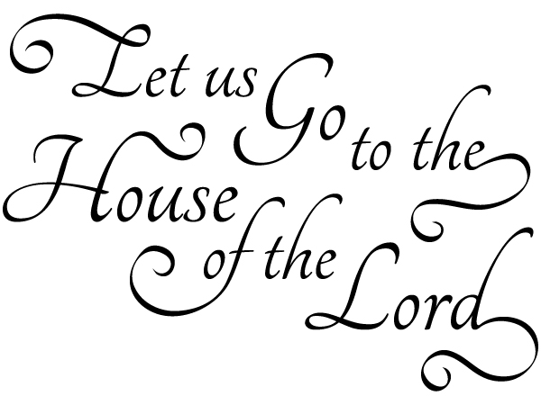

Acknowledgements
- All copyrighted materials reprinted under OneLicense.net # A-712592
- Speak, O Savior; I Am Listening Setting: © 1993 Elfred Bloedel. Used by permission.
- Preserve Your Word, O Savior Text: © 1941 Concordia Publishing House. Used by permission of CPH.
- Speak, O Lord Text, tune, setting: Keith Getty and Stuart Townend © 2006 Thankyou Music; admin. EMI CMG Publishing. International copyright secured. All rights reserved. Used by permission.
- Psalm 122: Music: Raymond Haan © 2005 All rights reserved. Used by permission.
- All images are from Paramentics.com or the WELS Hymnal Project Website, done by Ian Welch © 2013. All images are all rights reserved. Used by permission.

