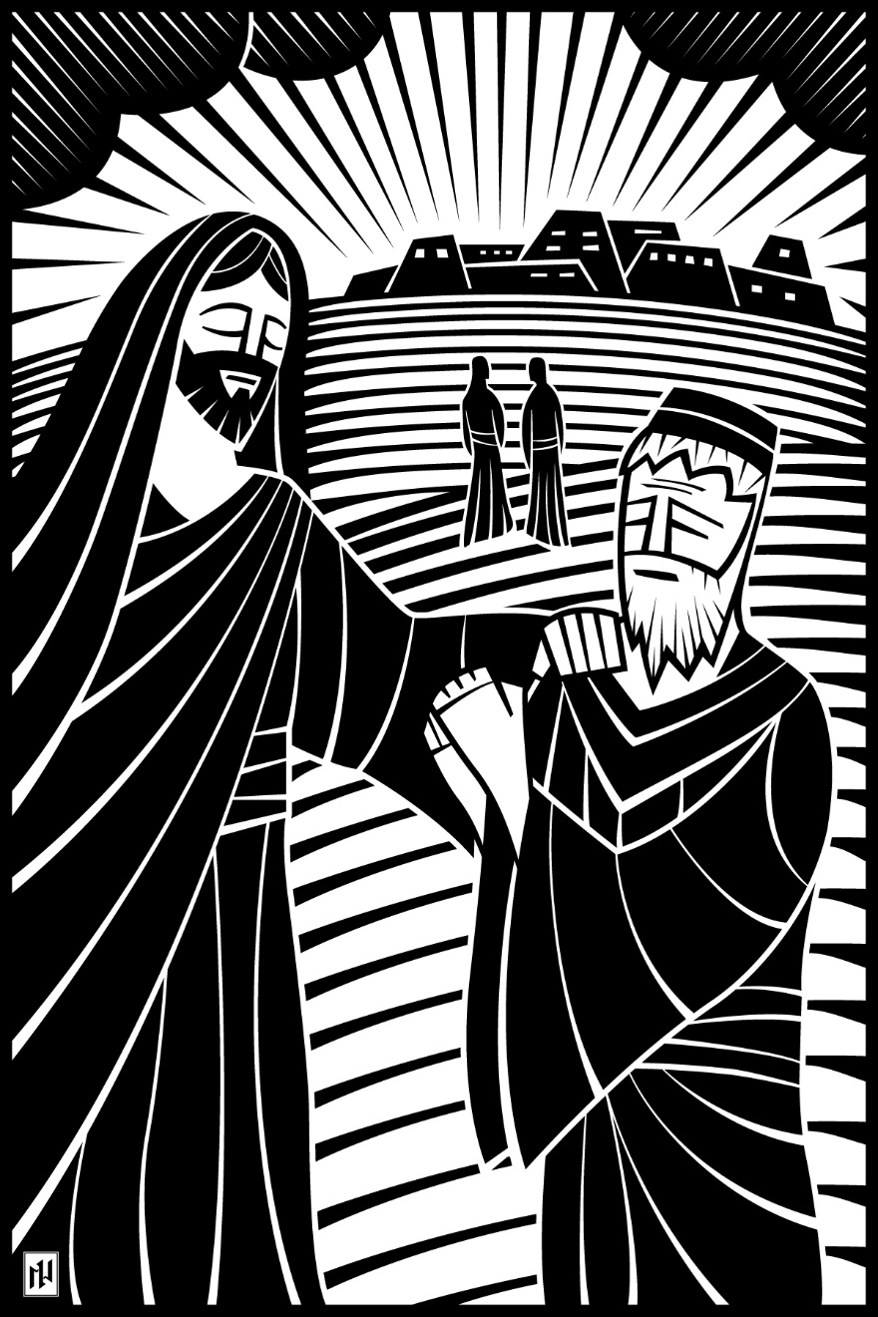
10th Sunday after Pentecost
The Christian Follows God…and Prays
August 22 and 25, 2019

In the name of our Lord Jesus, welcome! We pray that within our church you will find the quiet assurance of God’s presence, the warmth of Christian fellowship, and the abiding truth of God’s Word. Come worship with us again!

FOR VISITORS___________________________________________
• Visitor Cards: If this is your first visit to Zion, welcome! Please fill out a blue visitor card. You will find them in the pew racks and on the media counter in the lobby.
• Restrooms: The main restrooms are located just off the lobby. A family restroom is located down the hall from the library.
• Parents: You may use the library, lobby or fellowship hall for nursing or other childcare. Changing stations are provided in all restrooms.
• Sound: Hearing assistance is available for your use. Both the sanctuary and fellowship hall are equipped with hearing loops. Please set your hearing aid to the T (telecoil) setting. Portable audio receivers are also available from the ushers.
• Information: The media counter is located in the entryway. Here you will find magazines, brochures, devotional booklets, children’s bulletins, and more.
• Contact: Our pastors and principal are here to serve you. Contact information is provided below.

SERVING TODAY___________________________________________
Preaching Pastor Philip Heyer
Organist Paul Flath
Ushers (8:00) Jeff Henning, Daryl Berndt, Leo Fischer, Matt Weidner, Rodney Hacht, Mark Tiedt
Ushers (10:30) Jim Kluetzman, Gabe Uttech, AJ Uttech, Michael Uttech,
Rodney Cooley, Gary Schuhmacher
Communion Assistant (8:00) Leo Fischer
Communion Assistant (10:30) Nils Johansson
Greeters (8:00) John & Jane Evers
Greeters (10:30) Marcia Rewolinski and Arlene Sennhenn
Video Matt Greiling

CONTACT US___________________________________________
Website zioncolumbus.org
Office Phone 920-623-5180
Office Email office@zioncrusaders.com
Church Address 812 Western Avenue
School Address 822 Western Avenue
Pastor Tim Schwartz 509-480-2967; tschwartz24@gmail.com
Principal Alex Vandenberg 507-353-0719; avandenberg@zioncrusaders.com

DIVINE SERVICE II

OPENING HYMN What a Friend We Have in Jesus | CW 411

INVOCATION
Minister: In the name of the Father and of the Son and of the Holy Spirit.
Congregation: Amen.

CONFESSION
M: Dear friends, let us approach God with a true heart and confess our sins, asking him in the name of our Lord Jesus Christ to forgive us.
C: Lord of life, I confess that I am by nature dead in sin.
For faithless worrying and selfish pride,
For sins of habit and sins of choice,
For the evil I have done and the good I have failed to do,
You should cast me away from your presence forever.
O Lord, I am sorry for my sins. Forgive me, for Jesus’ sake.

ABSOLUTION
M: Christ has died. Christ is risen. Christ will come again. In his great mercy, God made us alive in Christ even when we were dead in our sins. Hear the word of Christ through his called servant: I forgive you all your sins in the name of the Father and of the Son (†) and of the Holy Spirit.
C: Amen.

LORD, HAVE MERCY |Kyrie Mark 10:47
M: In peace, let us pray to the Lord. For the well-being of all people everywhere, that they may receive from you all they need to sustain body and life, hear our prayer, O Lord.
C: Lord, have mercy.
M: For the spread of your life-giving gospel throughout the world, that all who are lost in sin may be brought to faith in you, hear our prayer, O Christ.
C: Christ, have mercy.
M: For patience and perseverance in this life, that we may not lose the hope of heaven as we await your return, hear our prayer, O Lord.
C: Lord, have mercy.
M: Lord of life, live in us that we may live for you.
C: Amen.
GLORY BE TO GOD | Gloria Sung to the tune of Come, Holy Ghost, Creator Blest | CW 177

1. All glory be to God on high!
Your name, O Lord, we glorify;
We praise you for your peace and grace,
Your favor toward our fallen race.

2. Our grateful thanks to you we bring,
For your great glory, heav’nly King,
For all, O Father, you have done
Through Jesus Christ, your only Son.

3. O Lamb of God, to you we pray.
You take all human sin away.
Have mercy, Lord; receive our prayer;
From God’s right hand, your mercy share.

4. You, Christ, are holy—Lord alone;
The Father’s glory you made known.
We by your Spirit sing again:
“All glory be to God!” Amen

THE WORD
SALUTATION
M: The Lord be with you.
C: And also with you.

PRAYER OF THE DAY
M: O Lord, your ears are always open to the prayers of your humble servants, who come to you in Jesus’ name. Teach us always to ask according to your will that we may never fail to obtain the blessings you have promised; through Jesus Christ, your Son, our Lord, who lives and reigns with you and the Holy Spirit, one God, now and forever.
C: Amen.

FIRST LESSON James 5:13-18 | NIV
I
s anyone among you in trouble? Let them pray. Is anyone happy? Let them sing songs of praise. ¹⁴ Is anyone among you sick? Let them call the elders of the church to pray over them and anoint them with oil in the name of the Lord. ¹⁵ And the prayer offered in faith will make the sick person well; the Lord will raise them up. If they have sinned, they will be forgiven. ¹⁶ Therefore confess your sins to each other and pray for each other so that you may be healed. The prayer of a righteous person is powerful and effective.
¹⁷ Elijah was a human being, even as we are. He prayed earnestly that it would not rain, and it did not rain on the land for three and a half years. ¹⁸ Again he prayed, and the heavens gave rain, and the earth produced its crops.
VERSE OF THE DAY

GOSPEL LESSON Luke 11:1-13 | NIV
M: The Gospel according to Luke, chapter 11.
C: Glory be to you, O Lord.

O
ne day Jesus was praying in a certain place. When he finished, one of his disciples said to him, “Lord, teach us to pray, just as John taught his disciples.”
² He said to them, “When you pray, say:
“ ‘Father,
hallowed be your name,
your kingdom come.
³ Give us each day our daily bread.
⁴ Forgive us our sins,
for we also forgive everyone who sins against us.
And lead us not into temptation.’ ”
⁵ Then Jesus said to them, “Suppose you have a friend, and you go to him at midnight and say, ‘Friend, lend me three loaves of bread; ⁶ a friend of mine on a journey has come to me, and I have no food to offer him.’ ⁷ And suppose the one inside answers, ‘Don’t bother me. The door is already locked, and my children and I are in bed. I can’t get up and give you anything.’ ⁸ I tell you, even though he will not get up and give you the bread because of friendship, yet because of your shameless audacity he will surely get up and give you as much as you need.
⁹ “So I say to you: Ask and it will be given to you; seek and you will find; knock and the door will be opened to you. ¹⁰ For everyone who asks receives; the one who seeks finds; and to the one who knocks, the door will be opened.
¹¹ “Which of you fathers, if your son asks for a fish, will give him a snake instead? ¹² Or if he asks for an egg, will give him a scorpion? ¹³ If you then, though you are evil, know how to give good gifts to your children, how much more will your Father in heaven give the Holy Spirit to those who ask him!”
M: This is the Gospel of the Lord.
C: Praise be to you, O Christ.

HYMN OF THE DAY When in the Hour Utmost Need | CW 413

LESSON Genesis 18:20-32 | NIV
T
hen the Lord said, “The outcry against Sodom and Gomorrah is so great and their sin so grievous ²¹ that I will go down and see if what they have done is as bad as the outcry that has reached me. If not, I will know.”
²² The men turned away and went toward Sodom, but Abraham remained standing before the Lord. ²³ Then Abraham approached him and said: “Will you sweep away the righteous with the wicked? ²⁴ What if there are fifty righteous people in the city? Will you really sweep it away and not spare the place for the sake of the fifty righteous people in it? ²⁵ Far be it from you to do such a thing—to kill the righteous with the wicked, treating the righteous and the wicked alike. Far be it from you! Will not the Judge of all the earth do right?”
²⁶ The Lord said, “If I find fifty righteous people in the city of Sodom, I will spare the whole place for their sake.”
²⁷ Then Abraham spoke up again: “Now that I have been so bold as to speak to the Lord, though I am nothing but dust and ashes, ²⁸ what if the number of the righteous is five less than fifty? Will you destroy the whole city for lack of five people?”
“If I find forty-five there,” he said, “I will not destroy it.”
²⁹ Once again he spoke to him, “What if only forty are found there?”
He said, “For the sake of forty, I will not do it.”
³⁰ Then he said, “May the Lord not be angry, but let me speak. What if only thirty can be found there?”
He answered, “I will not do it if I find thirty there.”
³¹ Abraham said, “Now that I have been so bold as to speak to the Lord, what if only twenty can be found there?”
He said, “For the sake of twenty, I will not destroy it.”
³² Then he said, “May the Lord not be angry, but let me speak just once more. What if only ten can be found there?”
He answered, “For the sake of ten, I will not destroy it.”

SERMON Pray Boldly and Persistently! | Genesis 18:20-32
- Boldly – because you know God’s will.
- Persistently – because you desire God’s will be done.
NICENE CREED
We believe in one God, the Father, the Almighty, maker of heaven and earth, of all that is, seen and unseen.
We believe in one Lord, Jesus Christ, the only Son of God, eternally begotten of the Father, God from God, Light from Light, true God from true God, begotten, not made, of one being with the Father. Through him all things were made. For us and for our salvation, he came down from heaven, was incarnate of the Holy Spirit and the virgin Mary, and became fully human. For our sake he was crucified under Pontius Pilate. He suffered death and was buried. On the third day he rose again in accordance with the Scriptures. He ascended into heaven and is seated at the right hand of the Father. He will come again in glory to judge the living and the dead, and his kingdom will have no end.
We believe in the Holy Spirit, the Lord, the giver of life, who proceeds from the Father and the Son, who in unity with the Father and the Son is worshiped and glorified, who has spoken through the prophets. We believe in one holy Christian and apostolic Church. We acknowledge one baptism for the forgiveness of sins. We look for the resurrection of the dead and the life of the world to come. Amen.

OFFERING
OFFERING PRAYER
M: Holy Lord, you made all things and gave us dominion over all you have made. Keep us from receiving your gifts with ingratitude, and help us to take responsibility for using them for your purpose and glory. Make us wise in the stewardship of all your creation, that we may preserve all you have made and that this good earth may be fruitful for the needs of all people everywhere.
C: Amen.

PRAYER OF THE CHURCH
M: Let us pray for the Lord’s mercy upon us and upon all people as they have need.
Brief silence
For the Word of the Lord to be preached freely and faithfully, that each sinner who hears repents and rejoices in the grace of forgiveness, let us pray to the Lord:
C: Lord, have mercy.
M: For this congregation and our life together around the Word and table of the Lord, that the work of God that goes forth from this place is blessed, let us pray to the Lord:
C: Lord, have mercy.
M: For all church workers who faithfully serve the Lord, let us pray to the Lord:
C: Lord, have mercy.
M: For the Lord to strengthen all families and bless the children entrusted to their care; for those widowed and orphaned, that they may be protected and cared for; and for the aged and infirm, that we may surround them with God’s love, let us pray to the Lord:
C: Lord, have mercy.
M: For peace in the world, for our nation and good government, for wise and faithful leaders, for those who protect our liberty in the armed forces, and for those who judge our laws and guard the rule of law among us, let us pray to the Lord:
C: Lord, have mercy.
M: For those who have wandered from the faith, for those who have been absent from the Lord’s house, for those whom we have hurt or wounded in word or deed, and for the reconciliation of all by the forgiveness of Christ, let us pray to the Lord:
C: Lord, have mercy.
Requested prayers
M: O gracious Lord, because we have known your love in Christ. You have promised to hear and give answer to the prayers of your people. We trust that you will supply all that is needed to all those for whom we have prayed and that you will guard your Church against all her enemies until the day when you will deliver us into your presence forevermore; through Jesus Christ, our Lord.
C: Amen.
THE SACRAMENT

M: The Lord be with you.
C: And also with you.
M: Lift up your hearts.
C: We lift them up to the Lord.
M: Let us give thanks to the Lord our God.
C: It is good and right so to do.
M: It is truly good and right that we should at all times and in all places
C: give you thanks, O Lord, holy Father,

M: almighty and everlasting God,
C: through Jesus Christ, our Lord,
M: who has called us to be his own so that we may live under him in his kingdom
C: and serve him in everlasting righteousness, innocence, and blessedness.
M: Therefore with all the saints on earth and hosts of heaven,
C: we praise your holy name and join their glorious song:

HOLY, HOLY, HOLY | Sanctus Isaiah 6:3; Matthew 21:9
Sung to the tune of O Savior, Precious Savior | CW 368

O holy, holy, holy
Lord God of pow’r and might,
Your glory, earth and heaven
In countless ways recite.
Hosanna! Come and save us,
Lord God of hosts on high,
And in your grace and mercy
Receive our fervent cry.
Hosanna in the highest!
How truly blest is he
Who in God’s name is coming
To set his people free!
He comes to bring salvation
And with his blood outpoured,
Deliver us from bondage—
Hosanna, mighty Lord!

PRAYER OF THANKSGIVING
M: Blessed are you, O Lord, because you have brought us from death to life.
C: With humble and repentant hearts, we praise and thank you for your Son, Jesus Christ.
M: He became our substitute under your holy law,
C: He destroyed the works of the devil by his perfect obedience to your will,
M: He willingly carried a cross to pay the debt of the world’s sin,
C: He lives and reigns to give us life.
M: Through his body and blood, once given and poured out for us,
C: forgive our sins and strengthen us for our journey heavenward.
M: Unite us to our crucified and risen Lord,
C: that we may believe in him,
M: that we may confess him,
C: that we may call on his name,
M: and finally be delivered from this world to the feast of the Lamb,
C: whose kingdom has no end. Amen.

LORD’S PRAYER Matthew 6:9-13
C: Our Father in heaven, hallowed be your name, your kingdom come, your will be done on earth as in heaven. Give us today our daily bread. Forgive us our sins, as we forgive those who sin against us. Lead us not into temptation, but deliver us from evil. For the kingdom, the power, and the glory are yours now and forever. Amen.

WORDS OF INSTITUTION Matthew 26:26-28; 1Corinthians 11:24.25
M: Our Lord Jesus Christ, on the night he was betrayed, took bread; and when he had given thanks, he broke it and gave it to his disciples, saying, “Take and eat; this is my (†) body, which is given for you. Do this in remembrance of me.”
Then he took the cup, gave thanks, and gave it to them, saying, “Drink from it, all of you; this is my (†) blood of the new covenant, which is poured out for you for the forgiveness of sins. Do this, whenever you drink it, in remembrance of me.”
The peace of the Lord be with you always.
C: Amen.

LAMB OF GOD | Agnus Dei John 1:29
COMMUNING AT ZION
Communion: If you are visiting today we ask you to speak to one of our pastors before communing. We follow the Biblical, ancient custom of close communion (also called “member communion”).
Confession: Receiving Holy Communion is a statement of faith. Any person who takes communion with a group of believers is publicly saying, “I believe everything this church teaches.”
Instruction: In order for people to understand the teachings that they are confessing when they take communion, we offer classes on the Christian faith in our church (and all of our WELS and ELS churches). We ask all visitors who have not yet received such instruction to first go through the classes before taking part in the Lord’s Supper.

DISTRIBUTION
DISTRIBUTION HYMNS Salvation unto Us Has Come | CW 390
If Your Beloved Son, O God | CW 393

SONG OF SIMEON Luke 2:29-32
Sung to the tune of The Church’s One Foundation | CW 538

C: O Lord, now let your servant
Depart in peace, assured:
For I have seen your promised
incarnate, saving Word—
A Light that will enlighten
All gloom where Gentiles dwell;
The brilliant, crowning glory
Of those in Israel!

All glory to the Father,
All glory to the Son,
All glory to the Spirit,
Forever three in one;
For as in the beginning,
Is now, shall ever be,
God’s triune name resounding
Through all eternity.

M: We give you thanks, O Lord, for the foretaste of the heavenly banquet that you have given us to eat and to drink in this sacrament. Through this gift you have fed our faith, nourished our hope, and strengthened our love. By your Spirit help us to live as your holy people until that day when you will receive us as your guests at the wedding supper of the Lamb, who lives and reigns with you and the Holy Spirit, one God, now and forever.
C: Amen.

BLESSING Numbers 6:24-26
M: The Lord bless you and keep you.
The Lord make his face shine on you and be gracious to you.
The Lord look on you with favor and (†) give you peace.
C: Amen.

CLOSING HYMN Christians, While on Earth Abiding | CW 408

Acknowledgments
- Divine Service II -2004 Northwestern Publishing House.
- General Verse © 2005 Dale Witte. Lamb of God ©2005 Dale Witte. Reprinted by permission. All rights reserved.
- All copyrighted materials reprinted under OneLicense.net # A-712592.
- When in the Hour of Utmost Need Setting: © 1982 Concordia Publishing House. Used by permission of CPH.
- If Your Beloved Son, O God Setting: © 1993 Kermit G. Moldenhauer. Used by permission.
- The introductory image is from Christian Worship Supplement ©2008, Northwestern Publishing House. All other images are from Paramentics.com, done by Ian Welch © 2013. For all images: All rights reserved. Used by permission.

