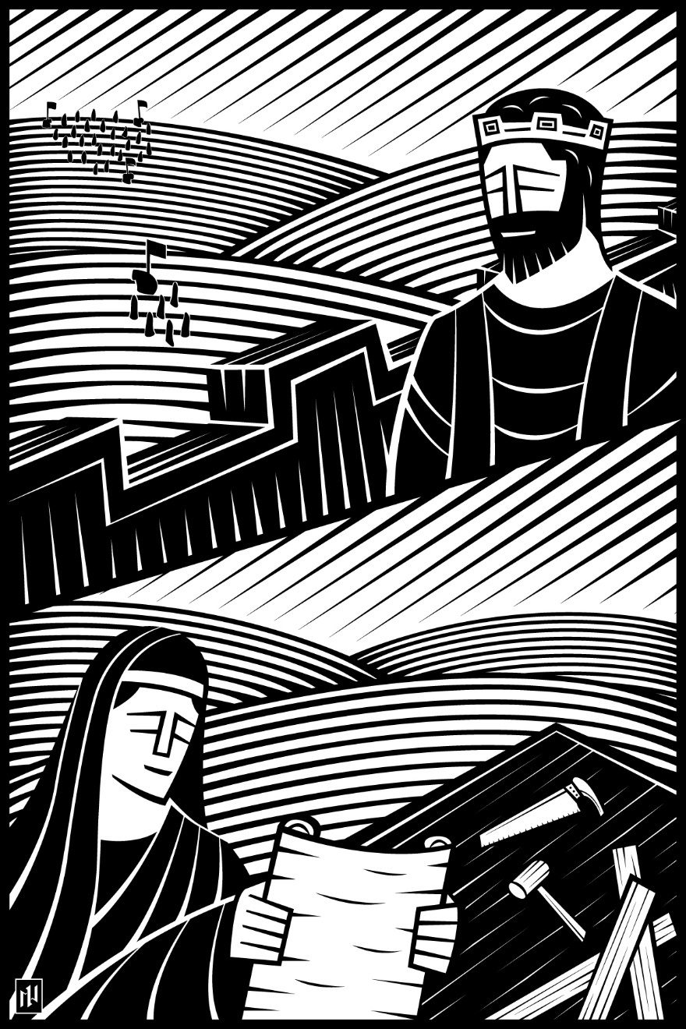
16th Sunday after Pentecost
Know the Cost of Following Jesus
September 26 and 29, 2019

In the name of our Lord Jesus, welcome! We pray that within our church you will find the quiet assurance of God’s presence, the warmth of Christian fellowship, and the abiding truth of God’s Word. Come worship with us again!

FOR VISITORS___________________________________________
- Visitor Cards: If this is your first visit to Zion, welcome! Please fill out a blue visitor card. You will find them in the pew racks and on the media counter in the lobby.
- Restrooms: The main restrooms are located just off the lobby. A family restroom is located down the hall from the library.
- Parents: You may use the library, lobby or fellowship hall for nursing or other childcare. Changing stations are provided in all restrooms.
- Sound: Hearing assistance is available for your use. Both the sanctuary and fellowship hall are equipped with hearing loops. Please set your hearing aid to the T (telecoil) setting. Portable audio receivers are also available from the ushers.
- Information: The media counter is located in the entryway. Here you will find magazines, brochures, devotional booklets, children’s bulletins, and more.
- Contact: Our pastors and principal are here to serve you. Contact information is provided below.

SERVING TODAY___________________________________________
Preaching Pastor Benjamin Zuberbier
Presiding Pastor Benjamin Zuberbier
Organist Paul Flath
Ushers (8:00) Mark Lindell, Remington Lindell, Roger Weiland, Bryce Weiland, Brett Weiland,
Norman Weiland, Eric Turnquist, Eliot Turnquist
Ushers (10:30) Otto Mattke, Paul Kehl, Dennis Winter, Carl Wolf, William Mattke,
Nils Johansson, Shaun Opsahl
Communion Assistant (8:00) Alex Vandenberg
Communion Assistant (10:30) Brian Baney
Greeters (8:00) Jim & Jenny Greiling
Greeters (10:30) Nils & Lara Johansson
Video Randy Koehn

CONTACT US___________________________________________
Website zioncolumbus.org
Office Phone 920-623-5180
Office Email office@zioncrusaders.com
Church Address 812 Western Avenue
School Address 822 Western Avenue
Pastor Ben Zuberbier 920-517-7940; pastorbenzuberbier@gmail.com
Pastor Tim Schwartz 509-480-2967; tschwartz24@gmail.com
Principal Alex Vandenberg 507-353-0719; avandenberg@zioncrusaders.com
SERVICE OF THE WORD AND SACRAMENT

OPENING HYMN Oh, Worship the King | CW 243

The grace of our Lord (†) Jesus Christ and the love of God and the fellowship of the Holy Spirit be with you.
And also with you.

CONFESSION OF SINS

God invites us to come into his presence and worship him with humble and penitent hearts. Therefore, let us acknowledge our sinfulness and ask him to forgive us.
Holy and merciful Father, I confess that I am by nature sinful, and that I have disobeyed you in my thoughts, words, and actions. I have done what is evil and failed to do what is good. For this I deserve your punishment both now and in eternity. But I am truly sorry for my sins, and trusting in my Savior Jesus Christ, I pray: Lord, have mercy on me, a sinner.
God, our heavenly Father, has been merciful to us and has given his only Son to be the atoning sacrifice for our sins. Therefore, as a called servant of Christ and by his authority, I forgive you all your sins in the name of the Father and of the Son (†) and of the Holy Spirit.
Amen.

PRAYER AND PRAISE

LORD HAVE MERCY | Kyrie
For all that we need in life and for the wisdom to use all your gifts with gratitude and joy, hear our prayer, O Lord.
For the steadfast assurance that nothing can separate us from your love and for the courage to stand firm against the assaults of Satan and every evil, hear our prayer, O Christ.

For the well-being of your holy Church in all the world and for those who offer here their worship and praise, hear our prayer, O Lord.

Merciful God, maker and preserver of life, uphold us by your power and keep us in your tender care:

The works of the Lord are great and glorious; his name is worthy of praise.
O LORD, OUR LORD
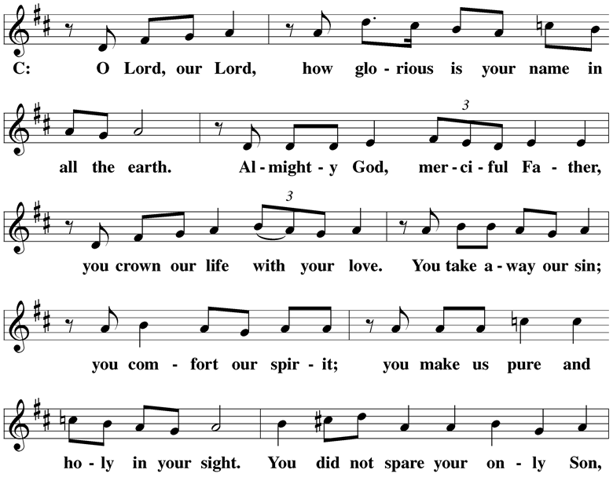

PRAYER OF THE DAY
Let your continual mercy, O Lord, cleanse and defend your Church; and because it cannot continue in safety without your help, protect and govern it always by your goodness; for you live and reign with the Father and the Holy Spirit, one God, now and forever.
Amen.
THE WORD
FIRST LESSON Genesis 12:1-8 | NIV
T
he Lord had said to Abram, “Go from your country, your people and your father’s household to the land I will show you.
² “I will make you into a great nation,
and I will bless you;
I will make your name great,
and you will be a blessing.
³ I will bless those who bless you,
and whoever curses you I will curse;
and all peoples on earth
will be blessed through you.”
⁴ So Abram went, as the Lord had told him; and Lot went with him. Abram was seventy-five years old when he set out from Harran. ⁵ He took his wife Sarai, his nephew Lot, all the possessions they had accumulated and the people they had acquired in Harran, and they set out for the land of Canaan, and they arrived there.
⁶ Abram traveled through the land as far as the site of the great tree of Moreh at Shechem. At that time the Canaanites were in the land. ⁷ The Lord appeared to Abram and said, “To your offspring I will give this land.” So he built an altar there to the Lord, who had appeared to him.
⁸ From there he went on toward the hills east of Bethel and pitched his tent, with Bethel on the west and Ai on the east. There he built an altar to the Lord and called on the name of the Lord.

SECOND LESSON Philippians 3:4b-11 | NIV
I
f someone else thinks they have reasons to put confidence in the flesh, I have more: ⁵ circumcised on the eighth day, of the people of Israel, of the tribe of Benjamin, a Hebrew of Hebrews; in regard to the law, a Pharisee; ⁶ as for zeal, persecuting the church; as for righteousness based on the law, faultless.
⁷ But whatever were gains to me I now consider loss for the sake of Christ. ⁸ What is more, I consider everything a loss because of the surpassing worth of knowing Christ Jesus my Lord, for whose sake I have lost all things. I consider them garbage, that I may gain Christ ⁹ and be found in him, not having a righteousness of my own that comes from the law, but that which is through faith in Christ—the righteousness that comes from God on the basis of faith. ¹⁰ I want to know Christ—yes, to know the power of his resurrection and participation in his sufferings, becoming like him in his death, ¹¹ and so, somehow, attaining to the resurrection from the dead.

VERSE OF THE DAY
GOSPEL LESSON Luke 14:25-33 | NIV
L
arge crowds were traveling with Jesus, and turning to them he said: ²⁶ “If anyone comes to me and does not hate father and mother, wife and children, brothers and sisters—yes, even their own life—such a person cannot be my disciple. ²⁷ And whoever does not carry their cross and follow me cannot be my disciple.
²⁸ “Suppose one of you wants to build a tower. Won’t you first sit down and estimate the cost to see if you have enough money to complete it? ²⁹ For if you lay the foundation and are not able to finish it, everyone who sees it will ridicule you, ³⁰ saying, ‘This person began to build and wasn’t able to finish.’
³¹ “Or suppose a king is about to go to war against another king. Won’t he first sit down and consider whether he is able with ten thousand men to oppose the one coming against him with twenty thousand? ³² If he is not able, he will send a delegation while the other is still a long way off and will ask for terms of peace. ³³ In the same way, those of you who do not give up everything you have cannot be my disciples.

This is the Gospel of the Lord.

HYMN Jesus, I My Cross Have Taken |CW 465

SERMON You Gain and Lose Everything at the Cross | Luke 14:25-33

NICENE CREED
We believe in one God, the Father, the Almighty, maker of heaven and earth, of all that is, seen and unseen.
We believe in one Lord, Jesus Christ, the only Son of God, eternally begotten of the Father, God from God, Light from Light, true God from true God, begotten, not made, of one being with the Father. Through him all things were made. For us and for our salvation, he came down from heaven, was incarnate of the Holy Spirit and the virgin Mary, and became fully human. For our sake he was crucified under Pontius Pilate. He suffered death and was buried. On the third day he rose again in accordance with the Scriptures. He ascended into heaven and is seated at the right hand of the Father. He will come again in glory to judge the living and the dead, and his kingdom will have no end.
We believe in the Holy Spirit, the Lord, the giver of life, who proceeds from the Father and the Son, who in unity with the Father and the Son is worshiped and glorified, who has spoken through the prophets. We believe in one holy Christian and apostolic Church. We acknowledge one baptism for the forgiveness of sins. We look for the resurrection of the dead and the life of the world to come. Amen.
OFFERING
OFFERING PRAYER
Glorious Lord, Jesus Christ, you have given us everything to assure us of our salvation. We can give you nothing except our thanks and praise. Receive these offerings as gifts from our hearts. Put them to use as we carry out the work to which you have called us. May the good news continue to abound in this place and spread to many more. In your name we pray.
Amen.

PRAYER OF THE CHURCH
Lord of power and grace, your eyes are on the righteous and your ears are open to their every request.
Hear the prayer of your people as we come now in thankfulness for the mercies that you extend to us daily.
We thank you for the gifts you provide in your almighty power and kindness.
Make us always aware that you have provided us with life, breath, and being. For the sake of your Son Jesus, bless the work of our hands, the words of our mouths, and the ambitions of our hearts, that we may serve you and one another.
We praise you for the gift of your Son, Jesus Christ, whom you sent to be the Savior of the world.
Grant that we may believe in him with all our hearts and learn from him the great truths he proclaimed.
Establish the rule of the Holy Spirit in our hearts, that we may produce the fruits of godly living.
May he make our faith unshakable, and work in us the ambition to do your will.
We pray for the nations of the earth. Bring down terror and tyranny everywhere. According to your will, raise up leaders who acknowledge that you are Lord over all the earth.
Bless our own nation. Lead it to cling to whatever is good and to turn from all that is wicked, that our people may prosper in integrity.
Special prayers and intercessions may follow.
Guide and uphold as we travel down the path of life to our heavenly home. Receive these petitions in the name of Jesus our Lord.
Amen.

THE LORD’S PRAYER
Our Father in heaven, hallowed be your name, your kingdom come, your will be done on earth as in heaven. Give us today our daily bread. Forgive us our sins as we forgive those who sin against us. Lead us not into temptation, but deliver us from evil. For the kingdom, the power and the glory are yours, now and forever. Amen.
THE SACRAMENT

The Lord be with you.
Lift up your hearts.
Let us give thanks to the Lord, our God.

Praise to the God and Father of our Lord Jesus Christ! In love he has blessed us with every spiritual blessing He sends the Holy Spirit to testify that we are his children and to strengthen us when we are weak. Now have come the salvation and the power and the kingdom of our God and the authority of his Christ. To him who sits on the throne and to the Lamb be praise and thanks and honor and glory forever and ever.

HOLY, HOLY, HOLY | Sanctus

WORDS OF INSTITUTION
Our Lord Jesus Christ, on the night he was betrayed, took bread; and when he had given thanks, he broke it and gave it to his disciples, saying, “Take and eat; this is my (†) body, which is given for you. Do this in remembrance of me.”
Then he took the cup, gave thanks, and gave it to them, saying, “Drink from it, all of you; this is my (†) blood of the new covenant, which is poured out for you for the forgiveness of sins. Do this, whenever you drink it, in remembrance of me.”
The peace of the Lord be with you always.
Amen.

O CHRIST, LAMB OF GOD | Agnus Dei
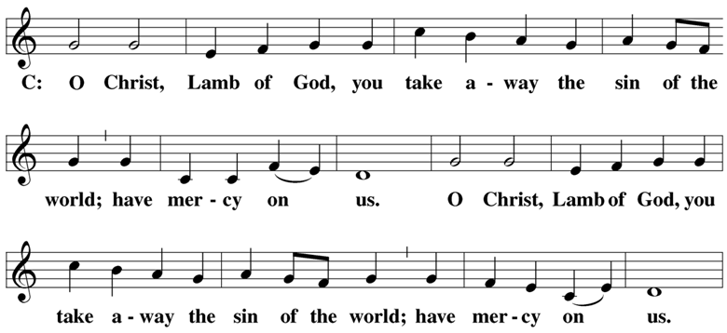

COMMUNING AT ZION
Communion: If you are visiting today we ask you to speak to one of our pastors before communing. We follow the Biblical, ancient custom of close communion (also called “member communion”).
Confession: Receiving Holy Communion is a statement of faith. Any person who takes communion with a group of believers is publicly saying, “I believe everything this church teaches.”
Instruction: In order for people to understand the teachings that they are confessing when they take communion, we offer classes on the Christian faith in our church (and all of our WELS and ELS churches). We ask all visitors who have not yet received such instruction to first go through the classes before taking part in the Lord’s Supper.

DISTRIBUTION

DISTRIBUTION HYMNS I Walk in Danger All the Way | CW 431
Come Follow Me, the Savior Spoke | CW 453

THANK THE LORD

Hear the prayer of your people, O Lord, that the lips which have praised you here may glorify you in the world, that the eyes which have seen the coming of your Son may long for his coming again, and that all who have received in his true body and blood the pledge of your forgiveness may be restored to live a new and holy life, through Jesus Christ, our Lord, who lives and reigns with you and the Holy Spirit, one God, now and forever.

Brothers and sisters, go in peace. Live in harmony with one another.
Serve the Lord with gladness.
The Lord bless you and keep you.
The Lord make his face shine on you and be gracious to you.
The Lord look on you with favor and (†) give you peace.

CLOSING HYMN God Be with You till We Meet Again | CW 327

Acknowledgements
- All copyrighted materials reprinted under OneLicense.net # A-712592
- The Kyrie, Song of Praise, and the Preface are all Tune: © 1993 Kurt J. Eggert. Used by permission. Setting: ©1993: Kermit G. Moldenhauer. Used by permission.
- Verse of the Day is Tune and Setting ©1993: Kermit G. Moldenhauer. Used by permission. Sanctus and Agnus Dei are Tune and Setting: © 1991 David Schack. Used by permission. Thank the Lord is Tune and Setting © 1978: Lutheran Book of Worship. Reprinted by permission of Augsburg Fortress. Written by Richard Hillert.
- The intro image for the service is from Christian Worship. All other images are from Paramentics.com or the WELS Hymnal Project Website, done by Ian Welch © 2013. All images are all rights reserved. Used by permission.

